Data availability statement:

Please provide a data availability statement. Here are examples for some generic cases:

- The data that support the findings of this article are openly available [citation].

- The data supporting this study's findings are available within the article.

Please provide the statement through the submission server at

<https://linkprotect.cudasvc.com/url?a=https%3a%2f%2fauthors.aps.org%2fSubmissions%2f&c=E,1,ICrccfEwuEfFbS1NGxsquAQxo853gKg3aD0Fk24XdytD5Qg0NOVkzrprsBQ7eZDTOBoxhWz7M4TQ5SsxXjKviFfs7JsJVvsmYI8xk6bql4G4EQ,,&typo=1>

For more information, please see

<https://linkprotect.cudasvc.com/url?a=https%3a%2f%2fjournals.aps.org%2fauthors%2fdata-availability-statements&c=E,1,goMyfpZw08PDdH0_vn7BQA0kfXCfGSu_oMARIELICaBl2DQOxvs963LYopWFBHefhRBEqhsxDC2789hvE2HgcTWkI6iZn2skiE-iOw-FqHrR6i8,&typo=1>

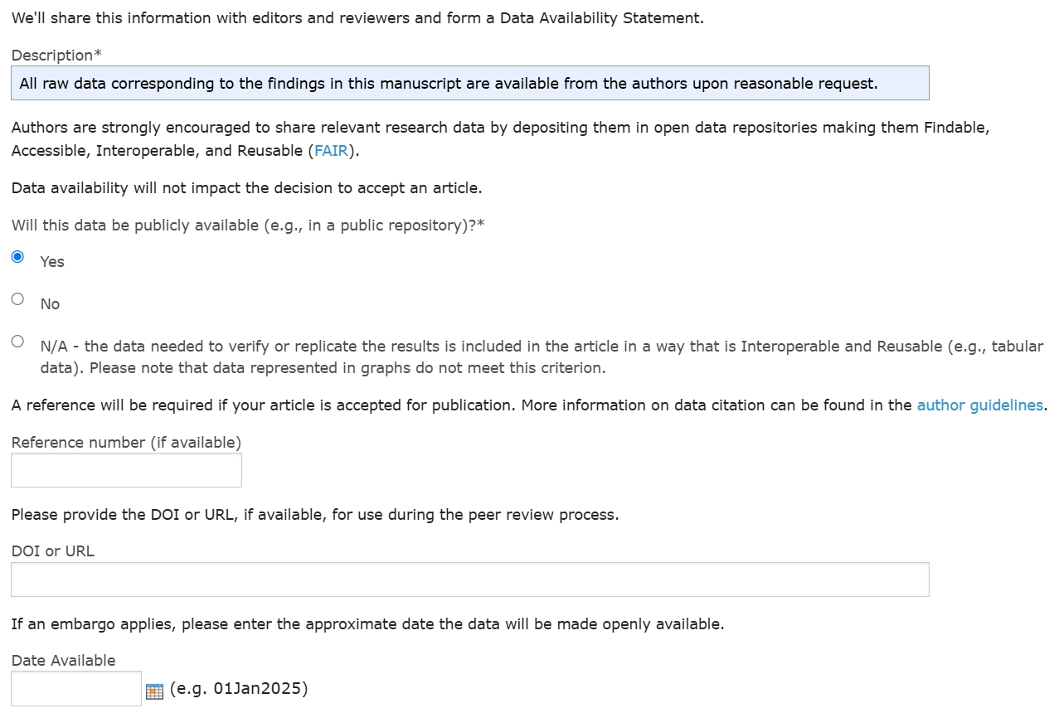

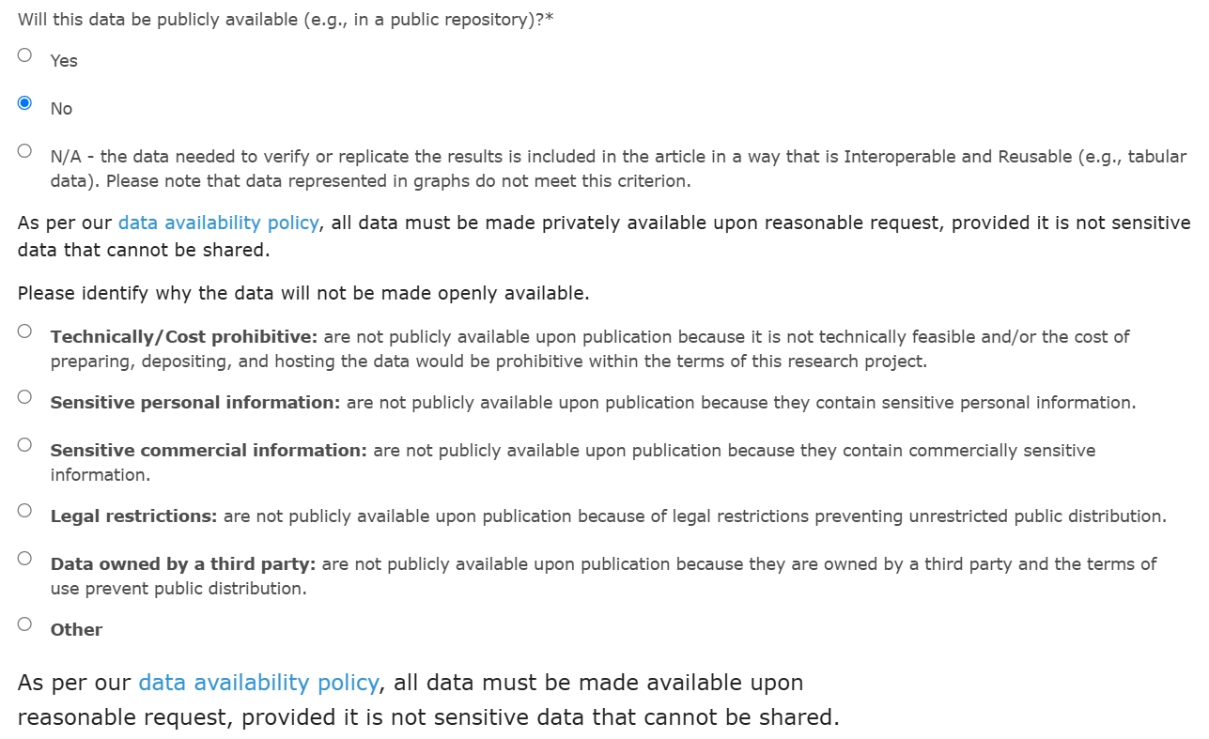

We appreciate the editor's time and effort in handling our submission! We have revised our manuscript according to the suggestions listed below.

Please address also the following technical editorial items:

1) Figure(s) [2] Please use 'min' for unit 'minute'. ('m' denotes 'meter'.)

Done.

2) Figure(s) [18] Please delete the background scale grid or lines.

Done.

Manuscript title:

1) We prefer the spelled-out form of a facility or apparatus name in the manuscript title (not the acronym itself), and we prefer not to place parts of the title in parentheses. However, the present, compact form of the title seems to require both. Have you considered a descriptive form of the title that would contain the spelled-out form as a subtitle, but not the acronym itself?

We changed the title to be "Lifetimes and Branching Ratios Apparatus".

The acronym "LIBRA" is defined in the abstract and in its initial mention in the main text.

*Alternatively, we could use something more descriptive like:*

*"Development of the Lifetimes and Branching Ratios Apparatus"*

*"Lifetimes and Branching Ratios Apparatus: Design and Performance"*

*"Design and Performance Test of the Lifetimes and Branching Ratios Apparatus for Proton-Unbound Nuclear States"*

Notation:

1) Please use TeX macros for characters from national alphabets, such as for names in the Bibliography. (Do not use characters from extended character sets. The corresponding file attributes don't transmit intact between file systems, including to the manuscript submission server.)

We have verified that no extended characters are used.

2) Please use "$\approx$" (not "$\sim$") to denote numerical proximity. Please adjust the notation throughout the manuscript.

Done.

Manuscript text (.tex source file):

1) Please ensure that the revised manuscript source file is free from "decorations" such as highlighting of changes made in the text. As useful as such annotations are, for the referee and also the editor, they will interfere with a smooth production process. (It is usually better to send a marked manuscript as a separate pdf file, as part of the response to the referee.)

We used \textcolor{darkred} to highlight the changes made in response to the review comments. We have removed all those annotations from the .tex source file.