SDT
During SDT time, the Fragment separator group will take beam. While the beam is there, a variety of tasks will up to the operators to complete in order to assist the FS scientists. The typical requests and their following tasks are listed below:
- An FS scientists will make an hourlog post with setting parameters for the beam dump, target velocity, dipole current setting, and F1S1. For this, operators must verify the settings from the hourlog post. This can be done by comparing the values listed on the Target Hall/ARIS status page. Once verified, clear the Target and Beam Dump PLC on MPS operator and make an hourlog post with the timestamp of the post from the FS group stating that those settings have been verified. 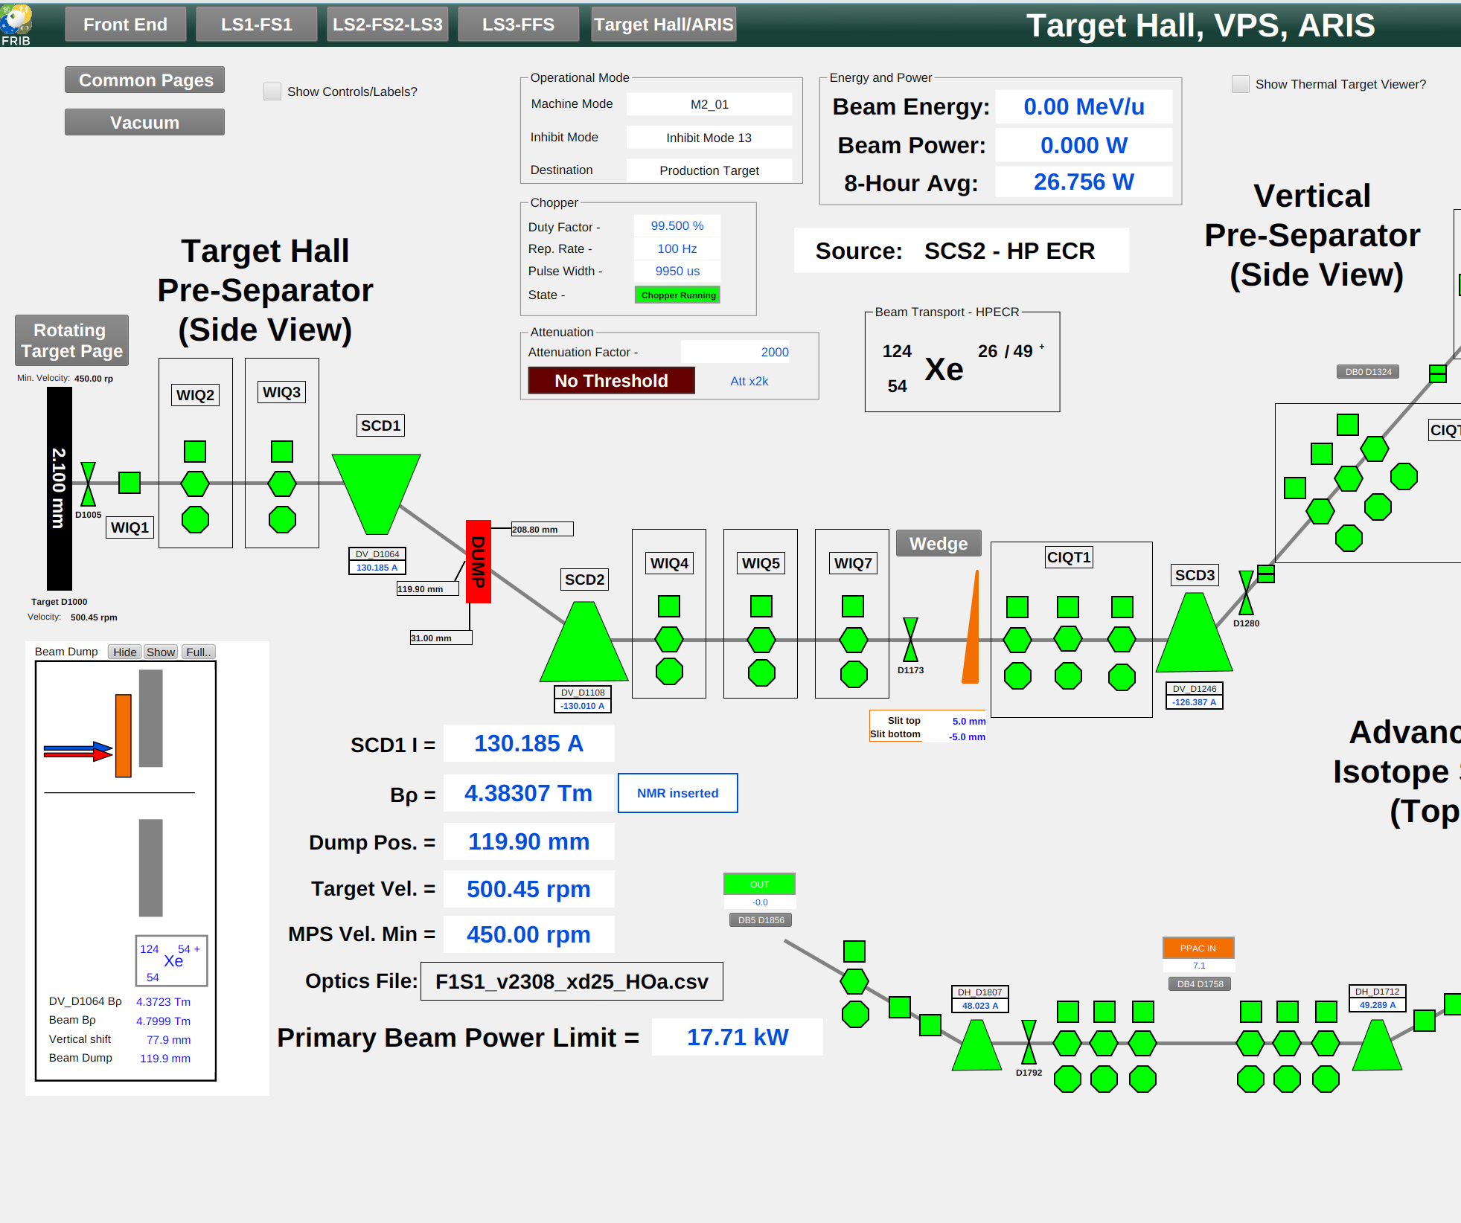
- Setting the DCCT On the DCCT's page found through the Diagnostics Launcher, under Hardware Overviews, there will be the DCCT at the bottom with the PV [FS_F1S1:DCCT_D1064]. You can follow this link, as the steps to set the DCCT are listed here [https://wikihost.frib.msu.edu/friboperators/doku.php?id=task:dcct_config]
- Configure BCM_5521 to based on new Primary Beam Power Limit. After the FS group has made their hourlog post, they may have updated the Primary Beam Power Limit(this is found also on the Target Hall/ARIS status page, just under the setting you verify from before.) Operators will need to take the new power limit and plug it into the physics caluclator, where the BCM info is. Take the new value, and go to the Diag TCT Overview page and find [BDS_FFS:BCM_D5789] and plug in the new value. 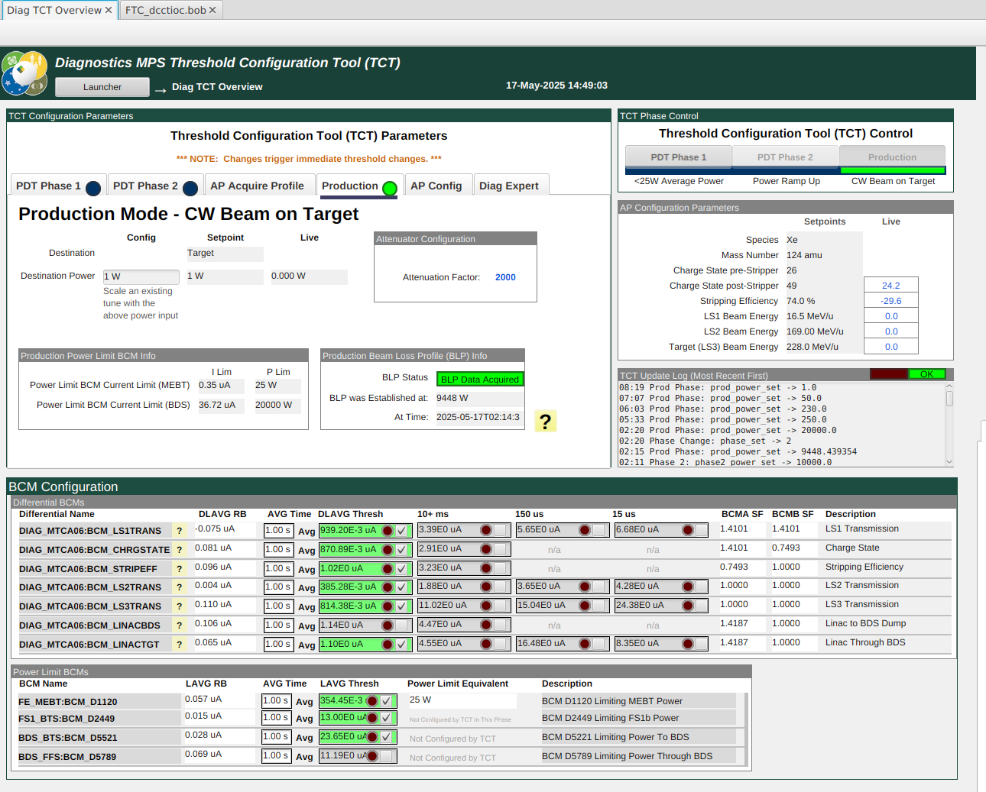

SN
- TEst

