Configuring MPS

Using MPS Operator Page

Using MPS Config Page
Dan has made a helpful tool to assist in setting the correct bits in MPS. From the FRIB Launch page click on MPS Config in the MPS section to open it. This tool has been known to burn operators is the past, only use it if you know it works and if it has been updated to reflect present MPS configuration changes. Location from launch page here.
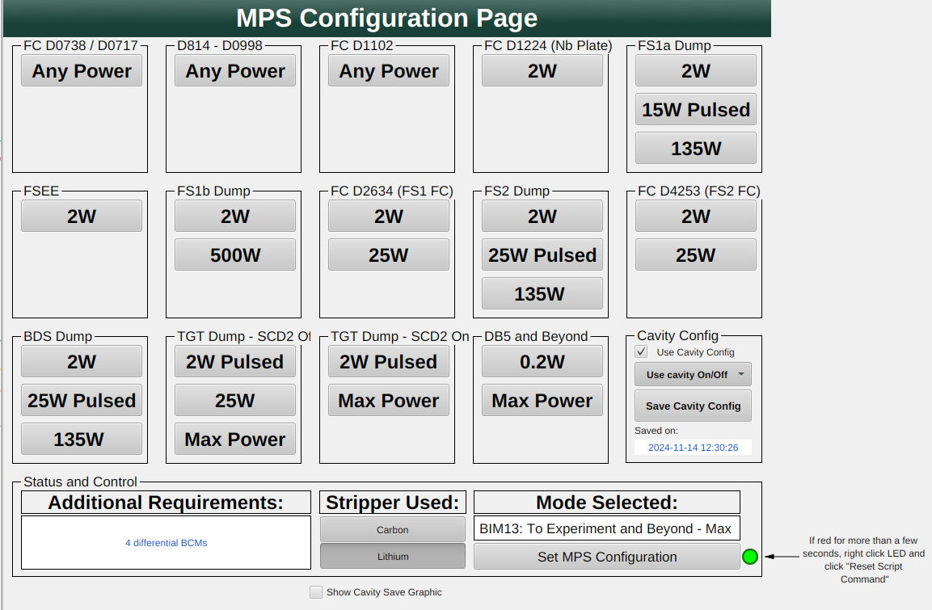Screenshot of the MPS Config page
To use it,
- Click on the desired power for the chosen destination.
- Decide whether to use a saved cavity config or not (see below for more).
- Verify that anything shown in Additional Requirements has been configured (this is not handled by the tool).
- Make sure the correct stripper is selected.
- If everything looks correct click the Set MPS Configuration button to apply it.
- Double check settings on MPS Operator page.

Cavity Config
When a mode requires watching cavities, the tool will normally enable watching all cavities in the relevant sections. In some cases not all cavities are being used, so to aid in only watching the needed cavities you can use the Cavity Config options.
To use Cavity Config tool on MPS Configuration tool with new cavity configuration, do the following:
- Click “Save Cavity Config” button.
- Check time stamp display
- Check “Use Cavity Config” checkbox.
To toggle whether MPS is watching any specific cavity, do the following:
- Open the MPS Operator page
- Scroll down until you see the following:
- 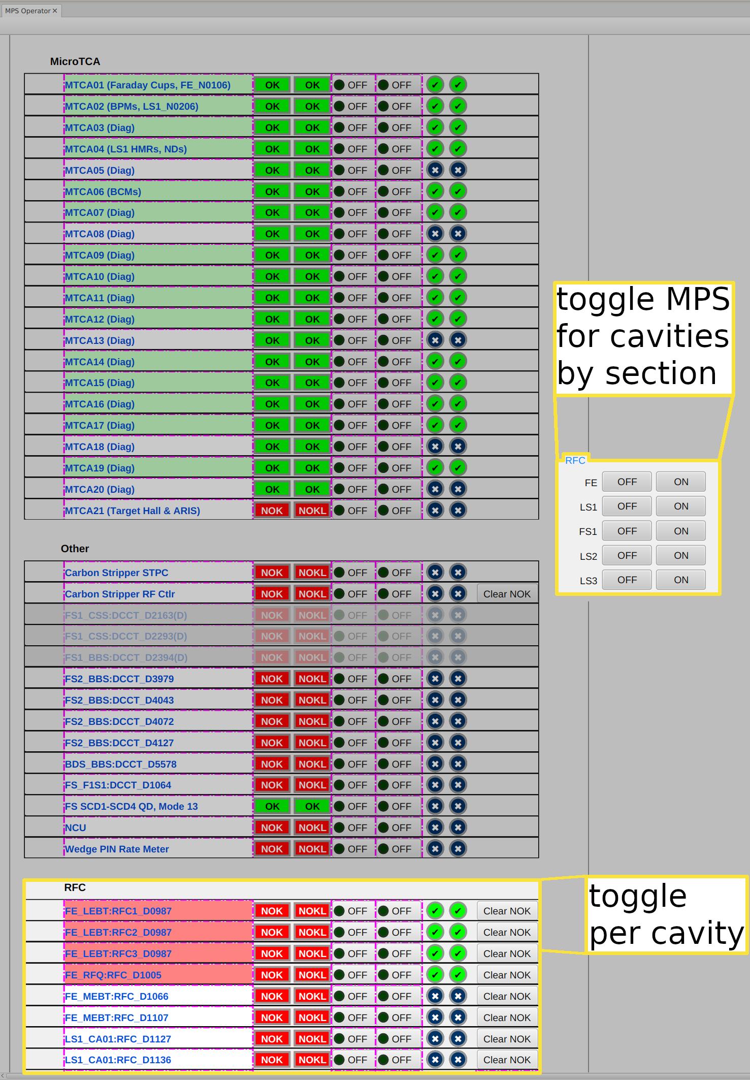
- Click OFF or ON to either start or stop watching ALL cavities in the corresponding section
OR
- Scroll to find any specific cavities
- Click both buttons corresponding to any cavities you'd like to toggle until they're either on or off, as shown:
- 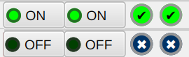
- Don't forget to cycle MPS to update!
NOTE: These buttons may need a few moments to apply relevant settings, or they may not work at all. This problem needs to be investigated further. DO NOT use this tool unless you double check its work.

Links
MPS Device Configuration Guideline

