Monitoring Ion Sources
source page here.
During beam operation, the sources will be on and will need to be monitored overnight when its just operators in the facility. The source group will usually leave instructions for operators to follow when they leave the facility. These are posted in the HourLog and may be printed as well.
For looking over the sources, it is usually good to keep an eye on the drain current. If this starts to go up or down drastically, or begins to become unstable, this may cause issues with beam power consistency. Likely operators will be instructed to increase of decrease the gas in the source by moving small steps until the drain current stabilizes again.
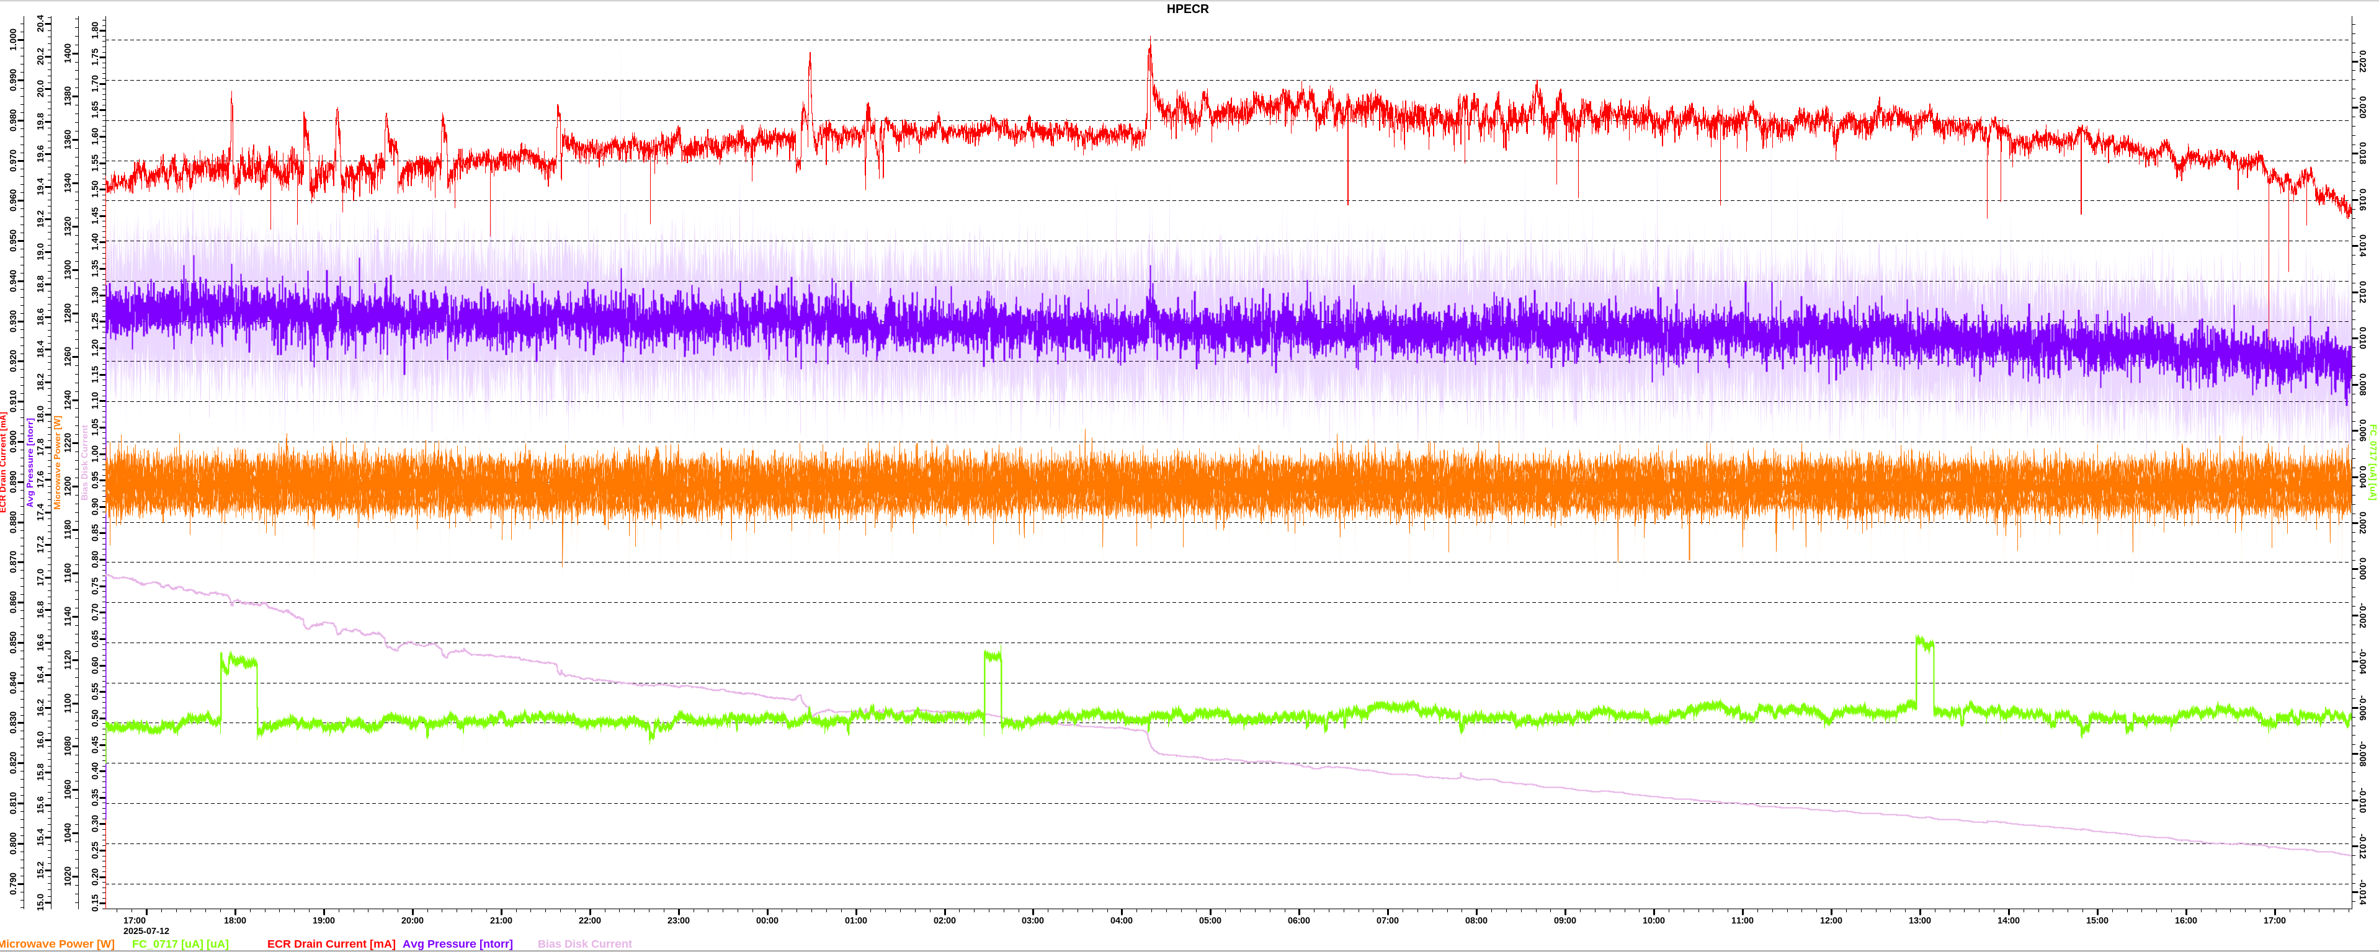
In the graph above, this is an example of the ECR drain current(Red Line) being unstable, identifiable due to the large fluctuations from #.### to #.###. This is usually when you may want to add or subtract some gas for the source. [def need some more detail here in what is best practice for this]

