Setting DCCTs

Disclaimer
While the setting of DCCTs is referenced in several procedures, there is no official guideline for what to set them to. The instructions below are just what has somehow become common practice.

Where to Find the DCCTs
- FRIB Homepage, Diag Launcher, Under “Engineering/Expert Pages”, DCCTs

Current practice
Currently operators are setting the DCCTs using the following steps:
- Disarm DCCT_D1064, note the magnet setpoint
- Set the negative and positive thresholds to 0.2% pf current magnet setpoint
- Clear the DCCT alarm, arm the DCCT
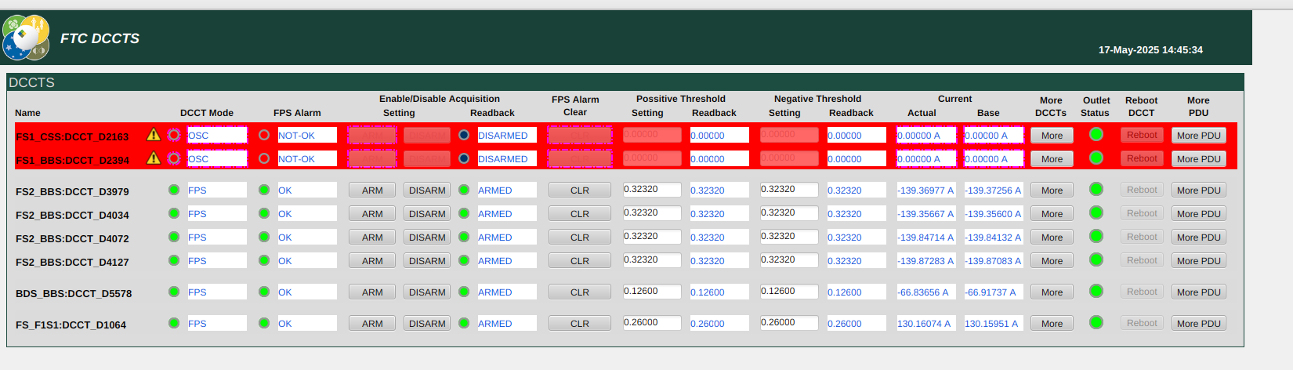

Setting the values
Most operators use their phone calculator or their computer calculator to make this calculation, the calculation usually fallows this syntax:
- (Current magnet setpoint) * 0.002 = threshold

Links
- DCCT Operation instructions
- DCCT info page

