Diag. Operator
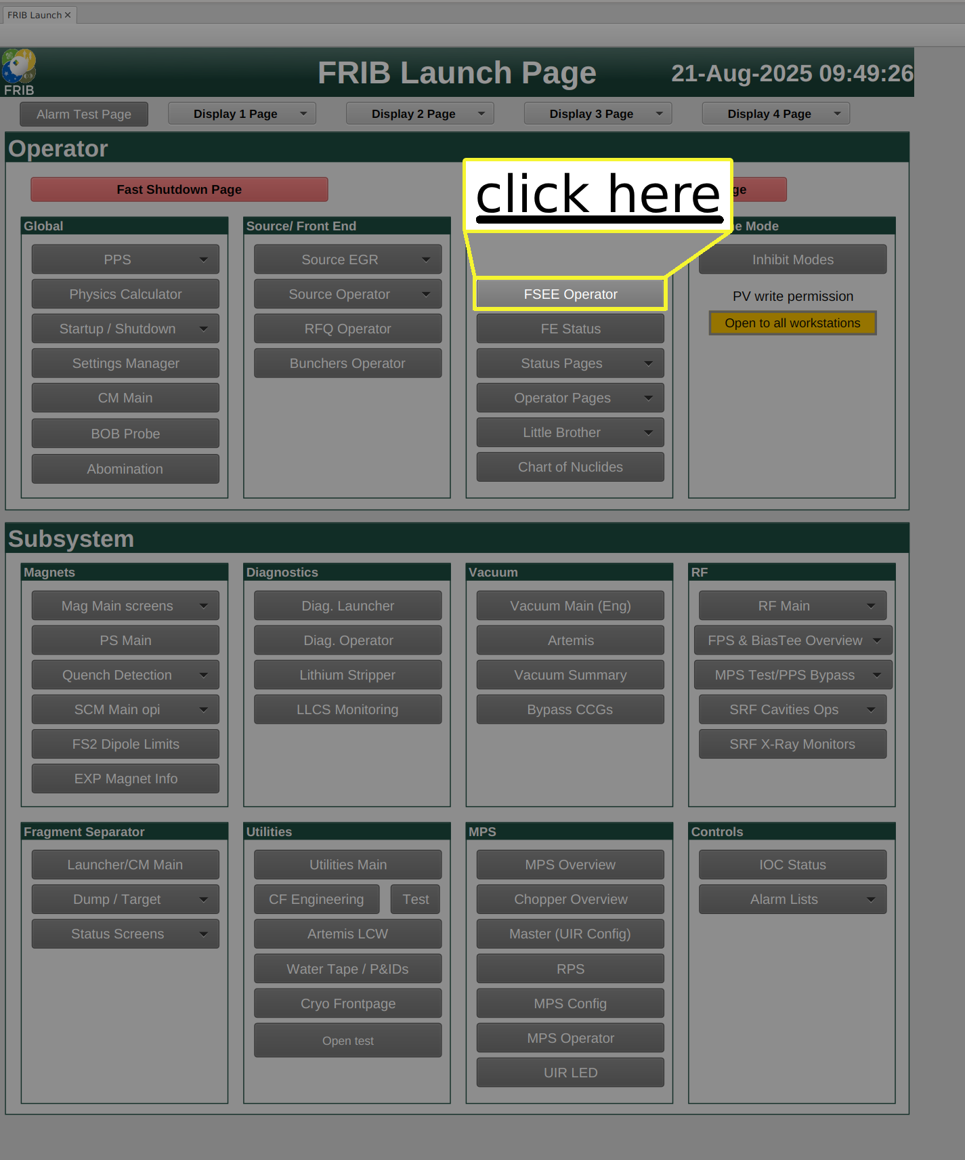
- Ater that you can go to whichever tab you like depending on the task at hand


