Faraday Cup

Info
Faraday Cups (FCs) are diagnostic devices that are inserted in the path of the beam to get a direct current reading. They can be sensitive to very low intensities and have higher fidelity than non-intercepting probes. The FC in the linac are all electrically biased and have a selectable range of sensitivities. Using a Faraday Cup means that beam needs to stop on it. This means that checking beam from the ion source (BCMs are not accurate at low energies), you must stop beam delivery downstream. This can be useful as an addition layer of protection when you stop the beam with the chopper. Several of the Beam Inhibit Modes rely on specific FCs indicating IN to be satisfied. At higher energies, neutron production becomes an issue so the beam intensity must be reduced to use FCs further downstream in the Linac. https://en.wikipedia.org/wiki/Faraday_cup
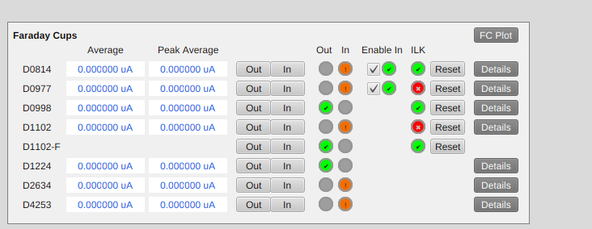Figure(1): This is the faraday cups on the FE Diag page.
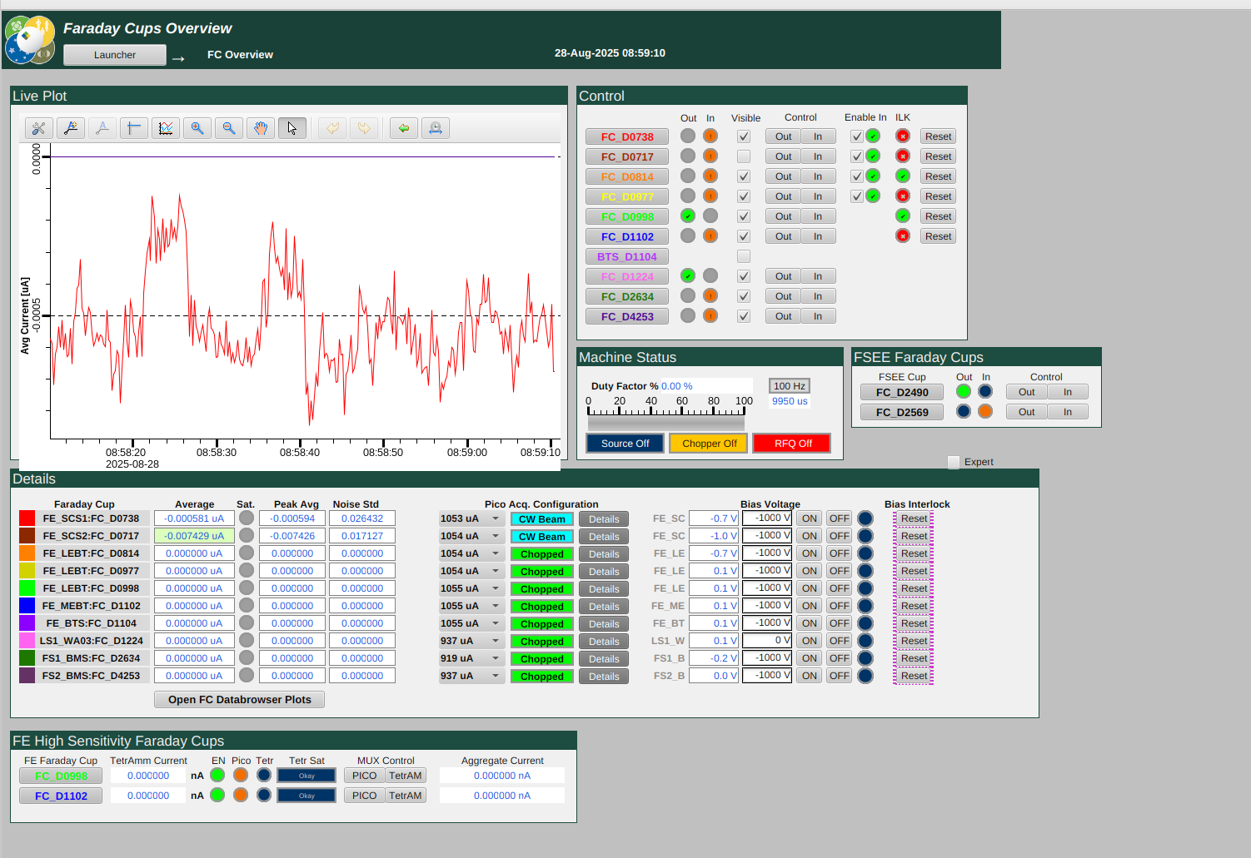
Through FRIB Main>Diag Launcher, there is the page meant just for the faraday cups.

Tips/Notes
- If the intensity seems to have plateaued no matter what tuning changes have been made it is likely outside of its range. Also if downstream cups read higher than earlier cups it is important to check that the bias is on. In some cases it is possible to mis-tune the beam so it is striking the edge of the cup, giving you an artificially high reading.
- The Phoebus page for them is here.

Location(s)
- Sources
- ULEBT
- LEBT
- MEBT
- LS1
- LS2
- LS3

PV's
- FC_D####

