E-Bends

Info
- The E-Bends consist of two pairs of electrostatic plates with each plate having its own separate power supply.
- The E-bends are responsible for bending the beam by 90 degrees two times.
  - First bend: beam goes from the ULEBT section down into the VLEBT section.
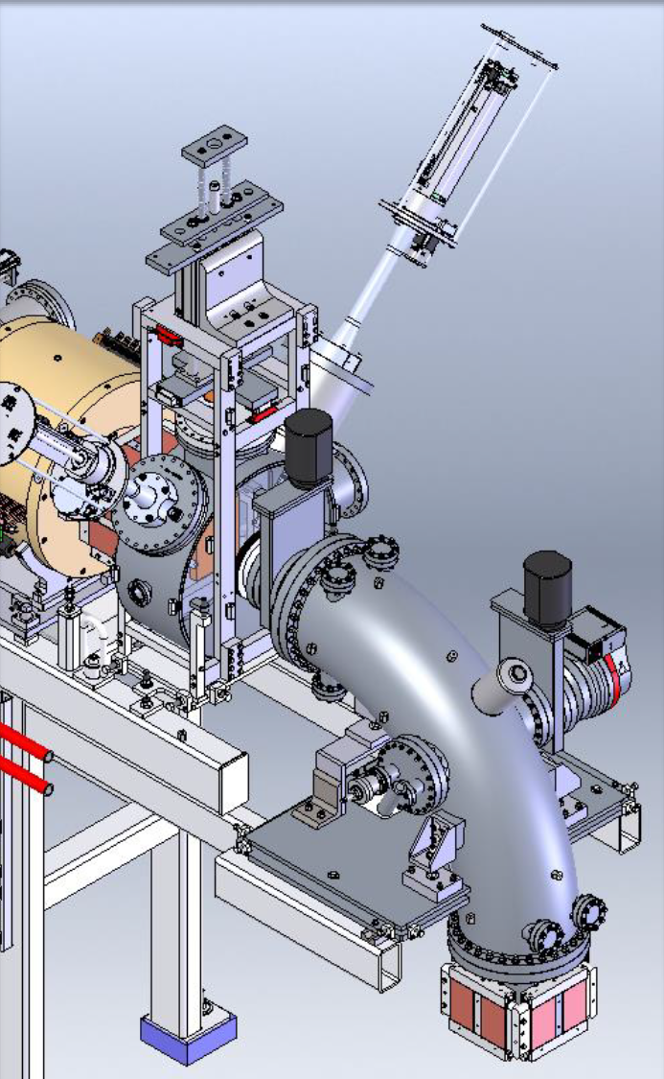Diagram of the first E-Bend.
  - Second bend: beam goes from the VLEBT section and into the linac tunnel.
- The plates of the E-Bends are inside the beam line.
  - In each pair, one plate is called the 'inner' plate while the other is called 'outer' plate. This is because the beam is bent in a circular fashion. So, one plate is near the inner radius of the bend while the other is near the outer radius.
- The E-Bends serve as beam inhibit devices as they ultimately determine whether or not beam can be sent into the linac tunnel to be accelerated.
- The plates are individually connected to a HV relay that prevents the plates from being charged from beam impact when the E-Bends' power supplies are turned off. These relays provide grounding; no charge accumulation can occur from beam impact on the plates that would otherwise cause inadvertent beam deflection into the linac tunnel.
- Since the E-Bends act as beam inhibit devices, their power supplies are tied to the PPS.
  - The Linac RSS system of the PPS must be in 'Beam Permit' before the PPS will allow the E-Bends' power supplies to be turned on.
  - If 'Beam Permit' is lost while the E-Bends are on, the PPS will quickly ground each of the plates and turn off their power supplies.

Tips/Notes
- When taking the Linac RSS out of Beam Permit, it is good practice to block beam upstream of the E-Bends and then turn off their power supplies before turning the key in the PPS rack.
- The controls for the E-Bend power supplies can be on found various pages. The most common page used by operators to turn the E-Bends on and off can be found by going to 'FRIB Launch Page' → 'MPS Operator'. Other pages are given under the Devices/PV's section of this page.
- When trying to turn the E-Bend power supplies back on after a period of not being in Beam Permit, wait ~10-15 seconds after the Beam Permit LED on the PPS rack has turned solid red before attempting to do so. This will give the PVs time to reconnect to CS Studio and thus be able to receive commands from CS Studio pages.
- All of the E-Bends power supplies should have similar voltage set point magnitudes with one supply in each pair being negatively biased.
- At present (August 27, 2025), three of the E-Bend power supplies ramp to their set points relatively quickly and with their readbacks ending up within a few hundred millivolts of their setpoints. The first supply, however, ramps more slowly than the others and usually the readback shows a difference of about two volts from the setpoint. The LED for this supply will still show that it is ramping even though the supply is done ramping. This small difference shouldn't alter the beam transmission in any meaningful way.

Location
The E-Bends are located at the top and bottom of the VLEBT section of the beamline.
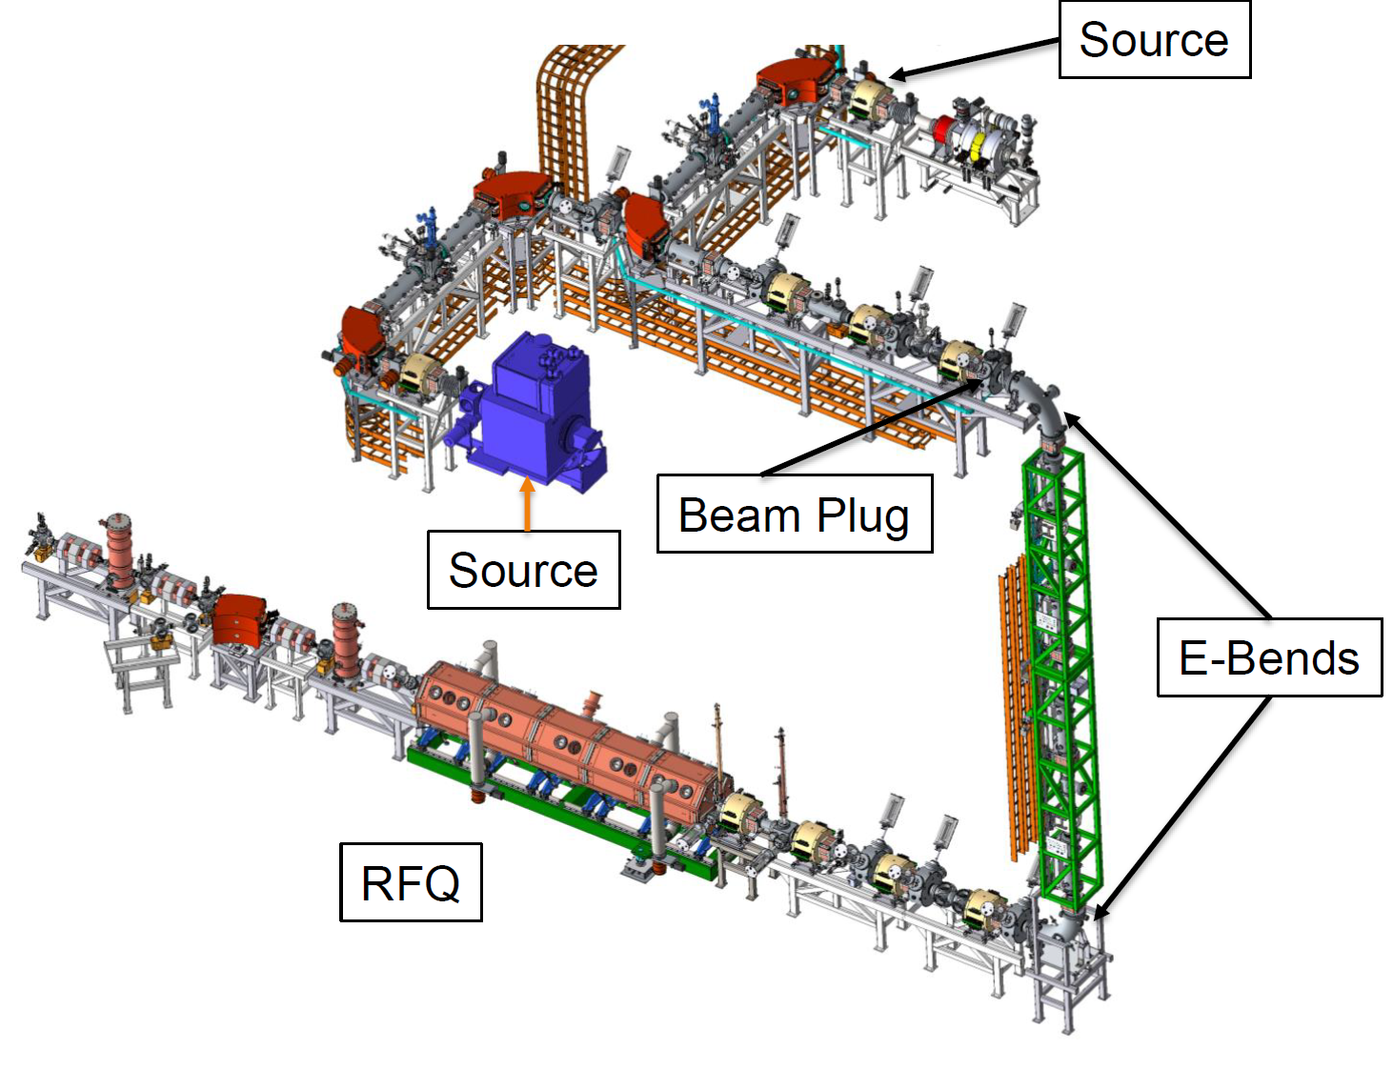Diagram of the Front End. The E-Bends are located at the top and bottom of the VLEBT section.

Devices/PV's
The PVs for the setpoints of the four power supplies for the E-Bend plates are:
- FE_LEBT:PSD1_D0833:V_CSET
- FE_LEBT:PSD2_D0833:V_CSET
- FE_LEBT:PSD1_D0936:V_CSET
- FE_LEBT:PSD2_D0936:V_CSET
These can be found by either going to 'FRIB Launch Page' → 'Mag Main screens' → 'Main Magnets' → 'V-LEBT' or 'FRIB Launch Page' → 'PS Main' → 'LEBT'. The E-Bends can also be turned on and off from these pages as well.

Personnel
There doesn't appear to be a single person/group in charge of the E-Bends. The power supplies themselves are probably owned by the Power Supply group. Any other problems with the E-Bends might be related to Controls/PPS group.

