Detailed git Commands

Cloning
- git clone
- To clone a new repo in order to work on it locally, copy the link to the repo on the corresponding BitBucket page.
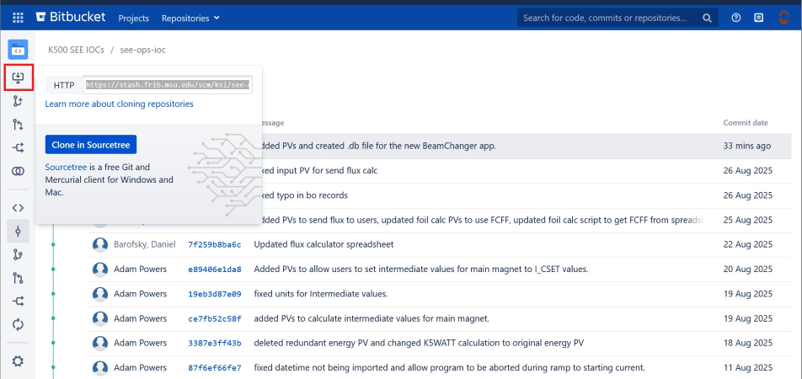
- Open a terminal in the folder you want to clone the repo into and type in git clone link
- This will create a local copy of the current state of the repo for you to work on.
- (To Add: Something about branching practices)

Pulling
- git pull
- In order to copy the most recent changes from the official repo to your local copy, open a terminal in the repo's corresponding folder and type in git pull
- If this throws an error, you may have uncommitted changes that need to be addressed in order to merge the two repos. (This can be avoided by branching).

Adding
- git add
- To stage all changes or created files to be committed, you can use the command git add -A

Committing
- git commit
- You can commit multiple times if you want to keep track of certain projects or files being changed in each commit.
- The modifier -a will grab all changed files and add them to the commit.
  - Note: this will not add new files to the commit.
- The modifier -m followed by parenthesis surrounding a message “commit message” will include the message to the commit.
- Ex: git commit -a -m “formatting changes to Beamline display”

Pushing
- git push
- This command pushes all staged commits to the official repo to be merged.

Merging
- To get your changes merged to the repo, create a pull request on the Bitbucket website.
- Ensure you are merging from the desired repo to the correct repo. In the below example, main to release/fc5
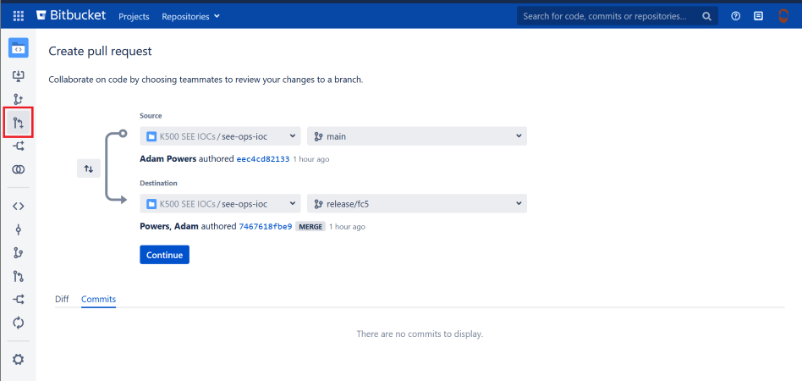
- After hitting continue, you will be met by the following screen, allowing you to change the title or body of your commit message. If there is not a Reviewer already populated, make sure you add one appropriate to the repo you are attempting to push to.


