Trigger for a TPC with AGET electronics
W.Mittig, 3rd july 2008

Introductory remarks
One may try to solve the trigger problem for the AT-TPC, with the conviction, that the more general context will be solved either by time-stamping, or any other decision during the time available before sending the "stop write SCA". Note that the SCA is running around clock, see slights by P.Baron at Bordeaux, and keeps in memory the information’s as long as you do not overwrite after one*nbucket. This leaves a programmable (and long, eventually longer than Tdrift for fast detectors) time available for external decisions. I do not try to discuss the ways to do these external decisions, eventually managed by some MT or GMT or GSI-GMT-UM, but to treat only what concerns directly the TPC, and more specifically the AGET. This seems the most urgent.
Hope my interpretation is correct that things may be decoupled in this way.

This means, it is NOT tried to include MUTANT or BEM in these considerations yet.

What is not discussed neither for the moment here, is the question if this type of logics as described below is treated in an analogical way, or numerically. First we should agree on the logical structure. A digital solution, in the logics described below, would have to have the same time structure as below, except some digitalization by a clock.

These remarks illustrate that this document is intended to be the basis of a first round discussion.

Remember the other questions by P.Baron on his slight 9.

AGET and trigger
As reminder of the functioning of the AGET electronics, I remind the slights shown by Pascal Baron at Bordeaux (http://indico.in2p3.fr/contributionDisplay.py?contribId=16&confId=901).
I re-used some of them below. As was discussed at Bordeaux, the discriminator output should have an adjustable length, programmable , and have an auto-reset at the end of this time.
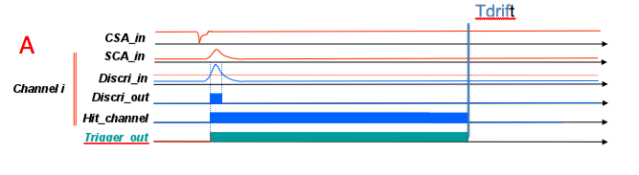
figure 1: individual channel Trigger out and Hit_channel signal

In the figure 2 below is given the scheme of P.Baron, with the intoduction of an internal reset of the “trigger out” and “hit register”. For clearness, below 2 cases, one without valid trigger, and the other with valid trigger. Note modifications with respect to the version of P/Baron, concerning the reset of “hit “ register and “trigger out”.
Below, the Trigger out and the Hit_channel are used in an identical manner; independent time duration programming of the signals could introduce some more possibilities.

Question 1: Check if this logic scheme concerning the hit channel register and trigger out is correct/convenient for you.

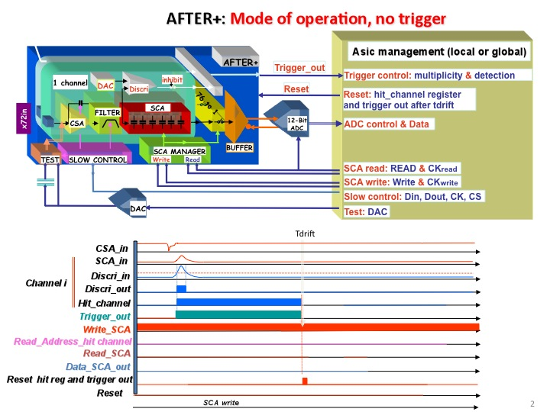

figure 2: mode of operation, no trigger; note change in reset of hit channel and trigger out with respect to the version of P.Baron at Bordeaux. A new, channel-individual and automatic reset is introduced in the lower part.

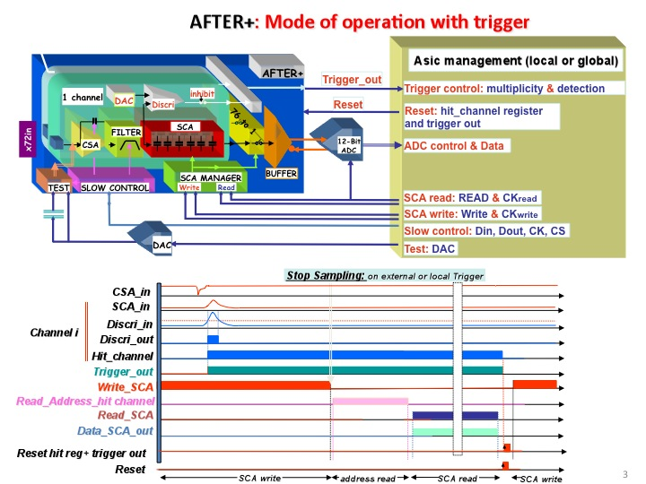

figure 3: mode of operation, with trigger; note change in reset of hit channel and trigger out with respect to the version of P.Baron at Bordeaux. A new reset is introduced in the lower part for the hit register and the trigger out. With respect to figure 2, it supposes that the internal reset at Tdrift of Hit-channel (and eventually Trigger out) is inhibited if there is a trigger signal, that stops the SCA write.

Trigger

We will here consider 3 trigger situations:
- An external detector gives the first trigger level
- The AT-TPC signals are used for the trigger
- Delayed implantation-decay experiment

Question 2: is the list of trigger situations complete (for the present discussion)?

Ad 1) An external detector gives the first trigger level

We will suppose that the external detectors have a timing that is fast as compared to the drift time of a TPC, such as scintillators, silicium detectors. The TPC information will then be used as a 2nd level trigger. For the general data acquisition structure, two cases may be distinguished: a) the drift-time is comparable to standard ADC holding time; b) the drift-time is comparable to standard ADC holding time. For standard gases such as isobuthane and P10, drift-times are of the order of 5cm/µs. For a 1m drift-space, this corresponds to 20µs. For H2 at 1atm, the drift-times will become long: drift velocity is 0.4cm/µs at 7kV/1m, and 1cm/µs at 70kV/cm approximately. Thus drift-times are in the range of 100-200µs. This is probably too long for keeping ADCs in a hold situation, and perhaps most convenient would be to treat this by independent data acquisitions with time-stamping.
The decision could be done in the following way (figure 4)

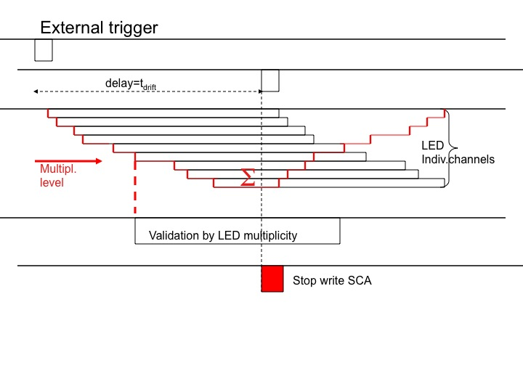
figure 4: Trigger logic with external trigger. The external trigger produces a pulse delayed by Tdrift. The analogical (or digital) sum of the individual “trigger out” signals is compared to a threshold, and gives a pulse of length Tdrift. The coincidence between the 2 pulses will provide the “stop write SCA” and initiate the read-out phase of the AGET (see figure 3).

Other more complicated decisions, such as choosing a multiplicity window, or making more complicated decisions (see below), as long as they are fast compared to Tdrift, can follow the same logic scheme.

Ad 2) The AT-TPC signals are used for the trigger

If no external detector is used, or the particles of interest do not leave the AT-TPC, one has to use the internal information of the AT-TPC. The use of the sum of the individual “trigger out” signals is illustrated on figure 5). We will call this “trigger-TPC” for shortness.
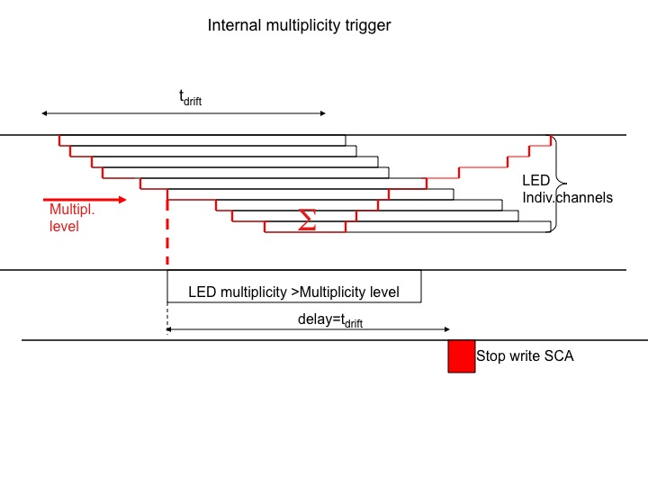
Figure 5: Trigger produced by the TPC. The analogical sum of the individual “trigger out” signals is compared to a threshold, and gives a pulse delayed by Tdrift, that will produce the “stop write SCA” signal and initiate the readout out phase (see figure 3).

As can be seen from this figure 5, the range of the SCA memory must cover now 2*Tdrift: because the signal is delayed by Tdrift, and may come with a delay between zero and Tdrift after the begin of the event, 2*Tdrift must be covered. This implies a specific difficulty: if the hit pattern is used for a selective readout, the hit-channel register may have reset internally (in the logic proposed). The most evident solution is just to program the delay of the internal reset of the “trigger out” and the “hit channel” to 2*Tdrift. The external delay(figure 5) will remain at Tdrift. The only inconvenience is a two times higher random pile-up in the sum signal. Order of magnitude: suppose 1000cts/s (beam region excluded, maximum data acquisition rate), and Tdrift=50µs. Then P=50*10⁻³=5%. Doubling the duration and hence the possible random coincidence rate to 2*Tdrift, will result in 10% randoms. Note that this difference of random rate only affects the pile-up in the sum of “trigger out”, and the read out of random channels.

Proposition 1: In the case of “trigger-TPC” and the use of the “hit channel” for selective read-out, the delay of internal reset may be 2*Tdrift.

Ad 3) Delayed implantation-decay experiment

The 2p decay is a typical case of this type. Hence this section should be carefully read by the Bordeaux participants. One can consider that this case is a sequence of the case 1 (external trigger) followed by case 2 (trigger TPC). The two phases are illustrated by the figure 3 and figure 5 respectively. We can decompose
- A beam detectors produces an external trigger signal, and a long window for blocking of beam and waiting for decay (“decay window”); internal reset-times of “hit” and “trigger out” must be set at 2*Tdrift to be compatible with next phase
- after Tdrift (about 10µs?) the “SCA stop write” signal is produced, without other condition
- a selective readout of the SCA is done (for evaluation of reading time see slight 6 of P.Baron, and it will depend on an optimized layout of ASAD for beam-particles to have the lowest possible hit-density/ASAD); 100µs??? (this would correspond to about 2000buckets/ASAD)
- as soon as the SCA read-out is finished, the AGET may receive a “SCA write” signal, (see figure 3), while the COBO transfers the data to the DAQ. This means the deadtime after implantation is of the order of 150µs(???, to be checked)
- during the decay window, the sum of “trigger out” signals is compared to a threshold;
- if it is above threshold, a signal “stop write SCA” will be produced, as in figure 5
- transfer of data to COBO and DAQ
- ready for next event

NB: if the decay window is less than or of the order of ~100-500µs, the implantation and decay may be covered in a single sequence, with, of course, the eventual difficulty to have in the same channel a highly ionizing event followed by a weekly one.

This type of procedure implies a more precise knowledge of the relative situation of the ASAD and the COBO. In a standard event, we can suppose that the “start write SCA” is delivered by the COBO (or the DAQ) at the end of a full transfer of the data. This is not part of the Trigger, but, strictly speaking, of a validation of trigger signals by the DAQ or the COBO.

Question 3: is the description of the implantation decay scenario correct? What are more precise needs and estimations? (Bordeaux)

Question 4: who produces the “end of event” in general?
(G. Wittwer, N.Usher?)

Question 5: how will it be possible to condition the “SCA write” by the end of transfer ASAD-COBO? (G. Wittwer, N.Usher?)

Multiplicity box and “trigger out” signals

Typically, there will be of the order 4*40 AGET, each with 72 channels; there will be one sum of “trigger out” per AGET; these can be regrouped on the ASAD

Question 7: One sum of “trigger out” per ASAD or one sum of “trigger out” per AGET?

Proposition 2 : one sum of “trigger out” per ASAD; in a first version of the Multiplicity box, a global sum of “trigger out” will be given. In later version the about 40 ASAD signals may be analysed in more complex way (multiplicity/ASAD,…)

Double Hits , deadtime and volume multiplicity

There was a question related to eventual dead-time problems: is there a use of very short “trigger out” signals? This could eventually decrease deadtime problems, and allow other types of multiplicity detection (as for example neutron multiplicity in the Orion detector). The type of multiplicity as discussed above gives the pad multiplicity, or the multiplicity projected on the x-y plane. It can be very useful, for example in the violent collisions, to get a volume multiplicity. If the time of the trigger out signal is short, the sum signal can be considered as a simple or of the channels. This would allow for having a total multiplicity counter for each AsAd, during a time Tdrift period after an external trigger, and a numerical sum of all the AsAd will provide a volume-multiplicity. Eventual problems may be multiple signals/channels, and channels that are noisy that may create wrong multiplicities. I would resume the question in the following way:

Question 6: what is the minimum width of “trigger out”? Is the use in the sum output (in this case it works more like an or) convenient for volume multiplicity?

In the case of short signals of the “trigger out”, it will probably be best to have independent and much longer hit_channel signals.

A more detailed point that was mentioned at Bordeaux, how to handle double hits. This is illustrated on the figure 1 below.
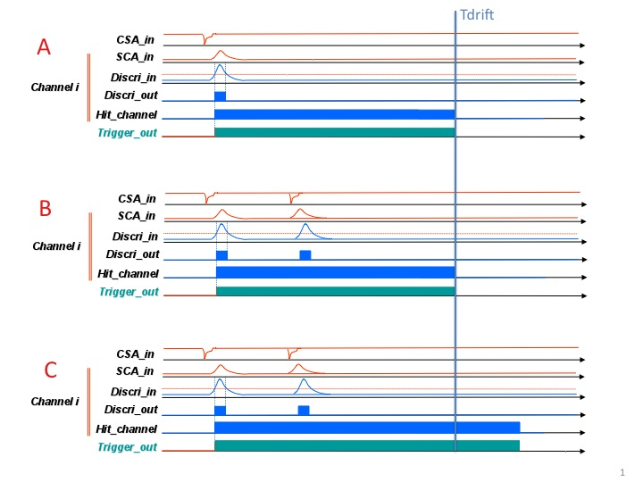

figure 1: Trigger output and hit channel register setting. Case A: a single event case; the length of the output is set to correspond to the maximum drift-time. The reset is internal at the end of this time. Case B: multiple hit event, without internal reset of the length. Case C: multiple hit event, with reset of the start.

As can be seen on the figure, in the case of a double hit in the pad i, if the first one is a random one and only the second one a “good”, one may loose the contribution of this pad in the multiplicity decision. Orders of magnitude: suppose an extreme total of 10⁵ events/second are seen by the TPC. Suppose a channel-occupation of 2%, this is 2.10³ hits/s for each pad. This supposes that most of the events are low multiplicity events. With a drift-time of 50µs, the random hit probability for two uncorrelated events is 100.10^{3.}10⁻⁶ =0.1=10%. This means the multiplicity as given by the sum of the trigger out, may be affected by the order of 10% of the events. An exact estimation is somewhat complicated, because the loss of real multiplicity is somewhat compensated by randoms. The multiplicity of this type of event is (using 2% and 10⁴ channels) is 200 and probably the events selected will be the most central collision with an occupation of at least 2 times more, this is 400. If the hit register is used for selective read-out, the random double hits may be lost if the end edge corresponding to the first pulse is out of the Tdrift window. In the case of multiple hit in the same pad during one Tdrift, as will occur frequently with high multiplicity events, the selective read out will not be affected.
In the case of low multiplicity and with exotic beams, the rate and the occupation is much lower, and hence the influence of such an effect much lower. In the case C, with reset of the length at a new hit, a new problem may arise, if, as commonly is the case, the discriminator will give a multiple signal after a real pulse (ringing).

Proposal 3: There will be no reset of the start of the “trigger out” or “hit register” for multiple hit events in the same channel.

Resumé

I suggest that for each project, there is one person who should initiate the discussion as local contact, and the present (and following on this subject) document will be sent to the following persons, as in the mail of E.Pollacco from 8th july 2008:

Riken/Kyoto: Tetsuya Murakami
Ganil: R. Raabe
MSU: W.Mittig ((Physicist in Charge)
Bordeaux: B.Blank
Saclay: J.E.Ducret
GB: Patrick Coleman Smith
GSI: Haik Simon (?)
Engineers: G.Wittwer(Ganil, Engineer in charge of TRIGGER – MUTANT/BEM), P.Baron(Saclay), E.Delagnes(Saclay)

Please let me know if you agree with this list.

The same document will be put on the wiki-site.
In the text above, there are questions and propositions, I suggest you to copy the text below and insert your answers and opinions.

A general question to answer is:

Question 0a: are there important points omitted or wrong? Is the decoupling of trigger problems correct?

Question 0b: is the definition of what is covered by the notation “Trigger” used here convenient for the definition of AGET and COBO (separation from DAQ, master trigger conception,…)?

Question 1: Check if the logic scheme concerning the hit channel register and trigger out (fig 2-3) is correct/convenient for you.

Question 2: is the list of trigger situations complete (for the present use)?

Question 3: is the description of the implantation decay scenario correct? What are more precise needs and estimations (Bordeaux)

Question 4: who produces the “end of event” in general?
(G. Wittwer, N.Usher?)

Question 5: how will it be possible to condition the “SCA write” by the end of transfer ASAD-COBO? (G. Wittwer, N.Usher?)

Question 6: what is the minimum width of the individual “trigger out”?

Question 7: One sum of “trigger out” per ASAD or one sum of “trigger out” per AGET?

Proposal 1: In the case of “trigger-TPC” and the use of the “hit channel” for selective read-out, the delay of internal reset may be 2*Tdrift.

Proposal 2 : one sum of “trigger out” per ASAD; in a first version of the Multiplicity box, a global sum of “trigger out” will be given. In later version the about 40 ASAD signals may be analysed in more complex way (multiplicity/ASAD,…)

Proposal 3: There will be no reset of the start of the “trigger out” or “hit register” for multiple hit events in the same channel.

