T2K Calibration Mode
Krista Meierbachtol
Last Modified: September 4, 2009

One available mode of operation for the T2K electronics acquisition system is a calibration mode. This mode allows for the testing of all 72 channels on each ASIC in order to determine the components’ operability and response characteristics to a fixed amount of input charge. The following document provides a summary of this mode including descriptions of the capabilities, implementation, and evaluation method.
This calibration mode will need to be employed prior to experimental data collection. This is due to the fact that each unique set of electronics running conditions has a set of associated transfer functions that depend on the chosen conditions. Each channel of each ASIC has its own transfer function that describes how the charge collected on the ASIC channel is transferred to an ADC channel value based on the electronics running conditions.
Capabilities
The calibration mode operates by generating and applying an equal amount of charge to all channels of each ASIC chip. The pulse generator is located on the Front End Card (FEC) board and is separate from the ASIC chip. It is capable of producing a range of pulse amplitudes, a useful feature for determining operational linearity and dynamic range(s) of the ASIC components. Channel selection is available to analyze one, or up to all 72, channel(s).
Implementation
Collection of calibration data can be done using the DAQ Control data acquisition program*. This program can be found on the TPC laptop computer. Using the calibration mode however requires using some acquisition settings that are usually ignored during regular data collection mode (referred to as ‘standard’ mode).
The first step in running the calibration mode is to set all the data acquisition types to calibration. This mode needs to be set in several different locations within the DAQ Control by locating the acqType option. These locations are: FEM(0), ASIC(0), ASIC(1), ASIC(2), and ASIC(3). The acqType setting needs to be toggled to read ‘calibration’ for each of these components. This option informs each of the components to expect a calibration pulse from the pulse generator. Figure 1 is a screen shot that includes the FEM(0) acqType and the ASIC(0) acqType locations. All the ASICs have identical setting options and should all have their acqType set to ‘calibration’. Each ASIC can hoever, have different gain and peaking time values from each other. These values are up to user discretion.
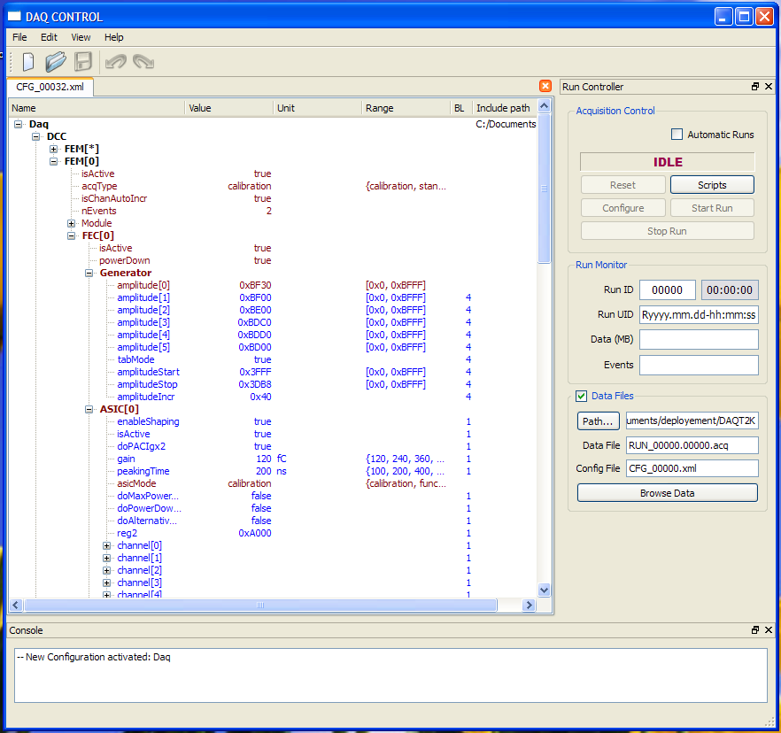
Figure 1: Screen shot of DAQ Control Panel with acquisition type settings for multiple components shown. Both are shown in red font.
The second step is to define the number of times the calibration of each channel should run. The number of iterations of the calibration is defined by the nEvents value found within the FEM(0) tab.
The next step is to select the settings of the pulse generator. The pulse generator built into these electronics has been designed to have two main modes of operation, as indicated by the true or false options of the tabMode setting of the Generator tab. Choosing true selects the pulse amplitude from a predefined list while the false option causes the pulse amplitude to be incremented Figure 2 is a screen shot displaying the control components of the pulse generator.
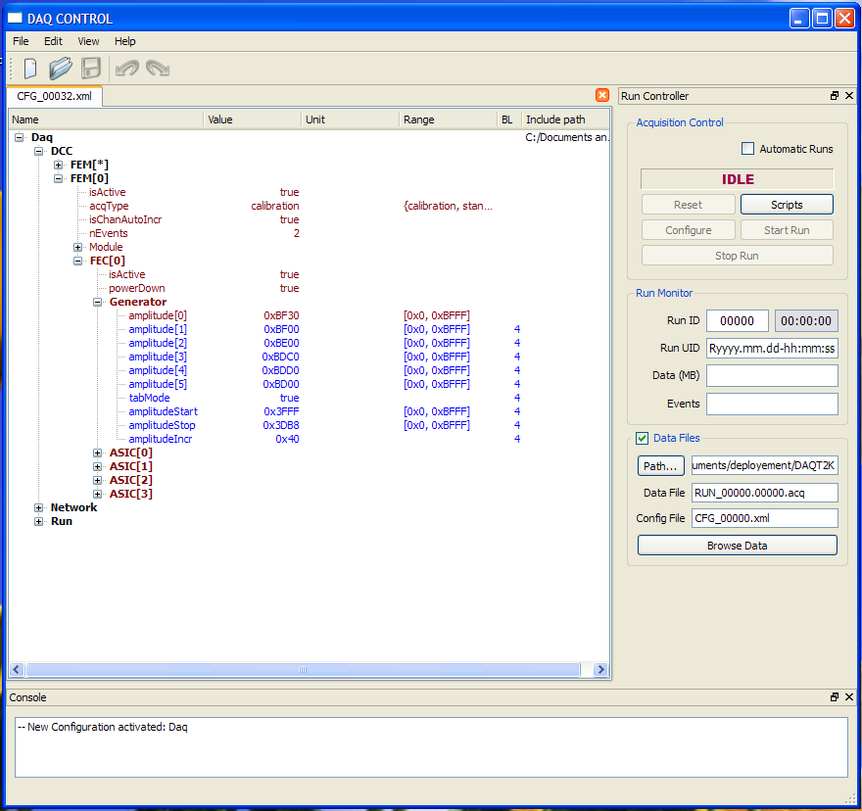
Figure 2: Pulse generator portion of the DAQ control panel. All the indent settings within the generator tab serve to define the pulse generator settings.
A true option for the tabMode activiates the six pulse amplitudes that are defined in hexadecimal format through amplitude[0], amplitude[1], amplitude[2], amplitude[3], amplitude[4], and amplitude[5]. The pulse generator steps through these six amplitudes during a calibration run. Six file segments are output that correspond to the same amplitude number. For example, RUN_#.00000.acq employed amplitude[0].
A false option for the tabMode activates a step-wise amplitude progression defined through start, stop, and increment values. These are defined in hexadecimal format with amplitudeStart, amplitudeStop, and amplitudeIncr settings.
The range column displays the range of hexadecimal values available for amplitudes, start, stop, and increment settings. The available range of the pulser amplitude is 0x000 – 0x3FFF, with the applied negative pulse height calculated by subtraction of the set value from the maximum. For example, a set amplitude value of 0x3000 results in an applied pulse with amplitude 0x3FFF-0x3000.
Finally, once a confirmation check of the expected output file segments has been performed, don’t forget to turn the power to the electronics off!

Evaluation
The transfer function of a single channel of an ASIC depends on the properties of the pulse generator and the settings of the ASIC being used.
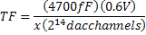
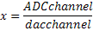
4700fF, 0.6V, and 2¹⁴dacchannels are properties of the on-board pulse generator, and x maps the dac channel onto the ADC. It is this x value that is dependent on the electronics settings, specifically the gain setting of the ASIC. The data output** in the file segments (corresponding to different pulse amplitudes) of a calibration file are used to evaluate the above transfer function because the amount of charge applied to an ASIC channel is known and set by the user.
The set of transfer functions correlated to the set of channels for each ASIC can be calculated with the root macro CalculateCalibConst.C, located in /projects/e09043/TestChamberCode/. The input file number and number of file segments can be specified in the command line (CalculateCalibConst.C(file#,#ofsegments)) or inside the root macro. The program creates a root tree that contains the calculated transfer functions for each channel of each ASIC. These values can then be applied to experimental data sets that use the same electronics running conditions.

*Notes on using the T2K electronics and the DAQ Control (DCC) data acquisition system.
- The T2K electronics are powered by a 5kV power supply which must be turned on prior to connecting the laptop to the electronics. This power should only be on when the electronics are in use.
- The DCC acquisition system variable settings are defined by the font color. Blue settings are default values while red means user-defined values. Right-clicking on the setting name and selecting ‘override’ allows for the change between blue and red types of settings.
- The run number will auto increment to the next available number in the location specified by the file path (shown in the lower right panel).
- Amplitudes are specified in hexadecimal values. A useful resource is the windows calculator that includes a convertor between decimal and hexadecimal.

**Note on data format for calibration runs.
The data output format of the calibration mode is different from the general acquisition mode of the DAQ control. The calibration mode collects data based on how the pulse generator input into the ASICs has been designed. The calibration data is collected for a single channel of all 4 ASICs and then iterated to the next channel number. Also, the nEvent number defines how many times each channel is pulsed and collected. For example, if the nEvent number is equal to 2, a single channel number (i.e. channel 1) will be pulsed 2 times on each ASIC before the pulser increments to the next channel number (i.e. channel 2).

