Programming: it seems necessary to start some simulations of pulses induced in pads.

All programs are in the folder pulsesimulation.

So I will take the following steps:
- use the program traject to calculate the trajectory (x,y,z,dE/s) about 100-1000pts
- the sections of trajectory are treated as points, with a broadening to a circle
by diffusion ( to be given by data), about 10 polar angles, 5 radii, normalization of initial charge conserved

- induction for wire-on a circle
-The induction is approximated by a circular pads, this means no dependance on orientation with respect to the charge
- Mathieson is used, this is exact for wire induction on pads
-only 10 by 10 pads (variable in program) are taken into account for the induction to limit; normalization of initial charge conserved
-formally there is a charge induced at a given time; no time delay between creation and induction is taken; this means no drift time of electrons to pads as would exist in GEMs is taken; no positive ion drift neither
- the detector is described by a 3-dim matrix, about 100(x),100(y),100(time); the spread out in x-y is obtained by Mathieson, as described above, and in time by an integration in time by a Gaussian distribution (with conservation of charge), that integrates the q(t) over the time buckets; the integration is given as data and corresponds to the shaping of the amplifier; this does not take into account that the pre-amplifier may saturate eventually before the amplifier, due to the longer time constant.

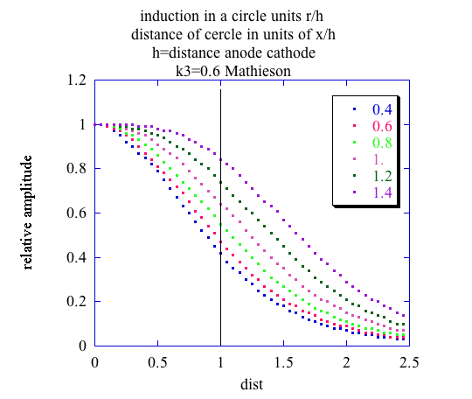
figure: charge induced; the different curves correspond to different diameters of the circles with respect to the distance wire-radius

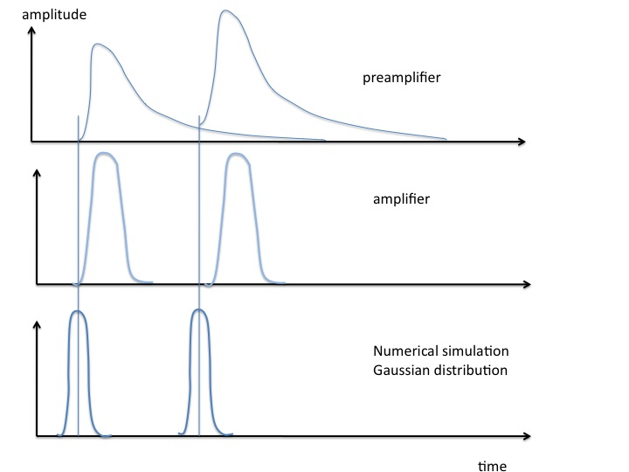
figure: schematic pulse shapes in PA and A, and the one to used for simulation

The charge induction will be calculated analytically.
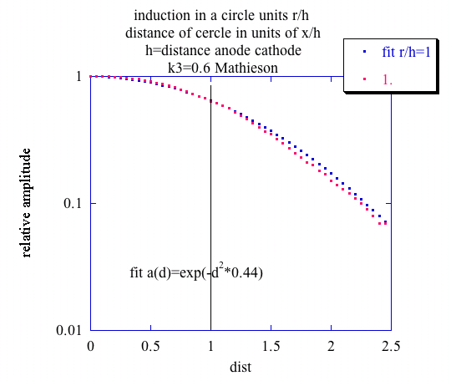
Figure: analytical description of induction: must be modified if other values of radius/h are wanted

Total number of integration steps:
Path: 1000
Diffusion:100
x-y:10*10=100
time:10
total:1000*100*100*10=10⁸ should be possible
structure of the program:
1)read x,y,z
2)calculate x,y,t-→ induction center
3)calculate diffusion effect in 3 dimensions -→ do over the diffusion elements normalize
4)calculate induction on +-5 pads in x,y , make Gaussian distr on time axis, add to old values
5) go to 1) until end of trajectory
6)print
7)plot separately (Kaleidagraph?)

5th may 2008

The program of induction in the 3-dim pads seems to work, see as example the figures below. The folder used is pulsesimulation.

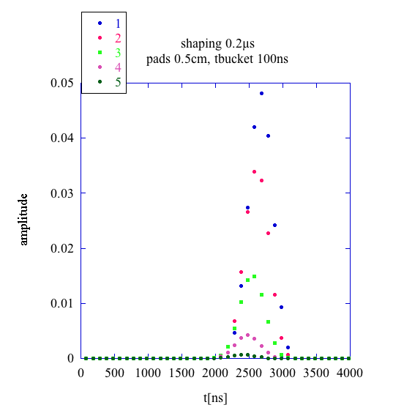
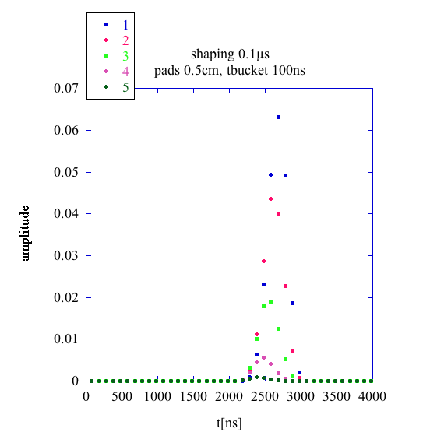

figures: calculated pulse shape for selected x-y pads

To plot in a convenient way, I will make an Euler transformation of the coordiantes.

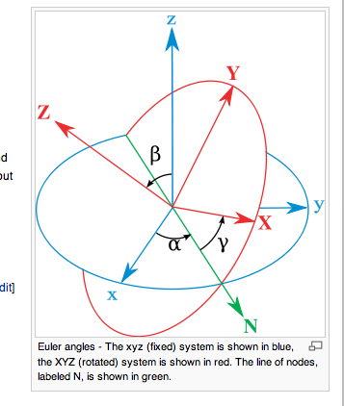

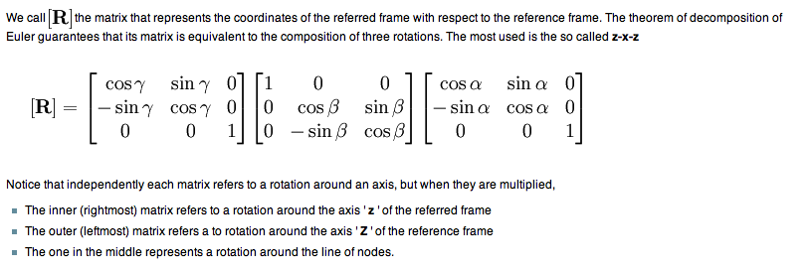

Euler transformation to project with a given angle

This seems easy to program.

6th may 2008

This effectively gives a quite nice plot of the trajectories:
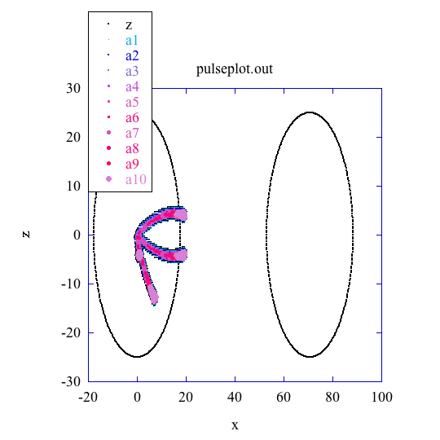

and with a zoom:
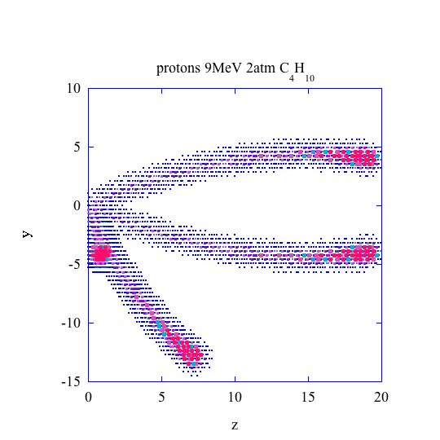
To be looked with more care, what are the Euler angles to make a nice projection. Her was used the following sructure in the program pulseplot:

program pulseplot
c prepares data for the plot the pulses induced in the detector AT-TPC
c reads pulsesimulation.out makes pulseplot.out
open( unit=3,file='pulseplot.out',status='unknown')
open( unit=4,file='pulsesim.out',status='old')
pi=3.14159265
r=25.
alpha=0.
c beta=0.
gamma=0.
alpha=pi*45./180.
beta=pi*90./180.
gamma=pi*45./180.
iprint=0
write(3,*)' x y z a1 a2 a3 a4 a5 a6 a7 a8 a9 a10'
do i=1,360
phi=2.*pi*i/360.
x=r*cos(phi)
y=r*sin(phi)
z=0
call euler(x,y,z,xp,yp,zp,alpha,beta,gamma,iprint)
iprint=0
write(3,100)xp,yp,zp
100 format(1h ,3f12.3)
enddo
do i=1,360
phi=2.*pi*i/360.
x=r*cos(phi)
y=r*sin(phi)
z=100. !must correspond to the driftdistance in TPC
call euler(x,y,z,xp,yp,zp,alpha,beta,gamma,iprint)
write(3,100)xp,yp,zp

enddo
c this will plot the 2 circles of the endcup of the TPC
c read data from pulsesimulation
write(*,*) 'lines to be skipped to read pulsesim.out'
read(*,*) iskip
do i=1,iskip
read(4,*)
enddo
amin=0.0001
amax=0.04
do 1000 iread=1,10000
read(4,*,end=2000)x,y,z,ampl
c retransform zp to cm instead of ns
z=z*5./1000.
call euler(x,y,z,xp,yp,zp,alpha,beta,gamma,iprint)
c create different symbols for plot Kaleidagraph
if(ampl.lt.amin) go to 1000
r=(ampl/(amax))
if(r.gt.1.)r=1.
pr=(r*10.+0.5)
ipr=pr
if(ipr.lt.1)ipr=1
write(3,1010)xp,yp,zp,(zp,i=1,ipr)
c bricolage
call euler(y,x,z,xp,yp,zp,alpha,beta,gamma,iprint)
c create different symbols for plot Kaleidagraph
if(ampl.lt.amin) go to 1000
r=(ampl/(amax))
if(r.gt.1.)r=1.
pr=(r*10.+0.5)
ipr=pr
if(ipr.lt.1)ipr=1
write(3,1010)xp,yp,zp,(zp,i=1,ipr)
call euler(-x,-y,z,xp,yp,zp,alpha,beta,gamma,iprint)
c create different symbols for plot Kaleidagraph
if(ampl.lt.amin) go to 1000
r=(ampl/(amax))
if(r.gt.1.)r=1.
pr=(r*10.+0.5)
ipr=pr
if(ipr.lt.1)ipr=1
write(3,1010)xp,yp,zp,(zp,i=1,ipr)

call euler(-x,y,z,xp,yp,zp,alpha,beta,gamma,iprint)
c create different symbols for plot Kaleidagraph
if(ampl.lt.amin) go to 1000
r=(ampl/(amax))
if(r.gt.1.)r=1.
pr=(r*10.+0.5)
ipr=pr
if(ipr.lt.1)ipr=1
write(3,1010)xp,yp,zp,(zp,i=1,ipr)

1010 format(2f8.2,12f8.2)
1000 continue
2000 continue

