Some considerations for the GET trigger logic.
4th November 2008-W.Mittig

Following the notes of P.Baron in annexe, I tried to make some more detailed simulations for the trigger logic.
The following assumptions were used:
- We can for the simulation make the analogical sum without taking into account the detailed structure of the ASAD due to the fact that the result is independent to the inverting of analogical and logic sum.
- Numerically, 25MHz was taken as ADC freq., multiplicity of 250 triggers, randomly distributed in an arrival window. Noise pulses were created, but even with 100/(s*channel) the effect is small. The length of the trigger signals was varied by +-15% randomly (see P.B.). the start of the trigger signal was taken as synchronized with the ADC clock (see PB).
- The analogical sum signal is converted every 40ns to a digital sum signal with a fixed delay
- the digital sum signal is integrated over a sliding time-window, here 3000ns, simulating the FPGA.
For more details see the comment on the figures and the program included. A good combination was a length of 80ns, with a delay of 20ns. The result is shown on figures 1 to 3. Figures 2 and 3 are zooms of figure 1. The multiplicity obtained is the double of the real because in 80ns 2 digital conversions occur.
As an example of a bad combination of length-adc frequency there are figures 4 and 5, with a length of 100ns, and a delay of respectively 30 and 20 ns.
A multiplicity of 750+3*noise should be obtained in this case, because in 100ns 3 digitalisations may occur. This is however unstable, due to edge effects in this case. On figure 4 (delay 20ns) the multiplicity is 650 only instead of 750; on figure 5 (delay 30ns), the result is better, but still somewhat low. These effects can be understood quite easily, of course. The program is given in annexe 2.
CONCLUSION for the trigger signal (output of the threshold/channel)
A unique length of for example 80ns with a delay of 20ns (dependant on the ADC clock cycle) is ok. There is no need to have this length adjustable. A jitter of the length of +-15% is acceptable, but should not be more.

The inhibit-deadtime for avoiding multiple triggering (ringing).
It seems to me that it is not necessary to have an adjustable length of this inhibit. A good compromise seems to me in the range of 3-5µs (to be fixed in discussion). Note that this inhibit will not imply that a second real pulse during this time will not be registered/read: the hit register will be set to 1 in any case, and hence even in a selective read-out, all the time-buckets will be read. If not too complicated, one could consider the option of this inhibit on/off. The jitter of length is not important.
Conclusion for the inhibit-deadtime for avoiding multiple triggering (ringing).
A single length of 3-5µs (the exact value to be fixed in next phone conference) is enough. If not too much complication, the option on/off could be implemented.

Question about the output dynamic of the trigger signal (from annexe 1,PB).
The trigger signal is the analog sum of the 72 discriminator outputs. This implies that we must be able to detect a multiplicity of 1 to 72? Or only 1 to m levels?
The logics of a limitation of maximum multiplicity at this level is somewhat difficult to analyse. It could introduce biased probabilities in the trigger decision, dependant on the geometry of the event. So I would recommend to keep the multiplicity 72. The precision does not have to be very high, I would suggest 5-10%?

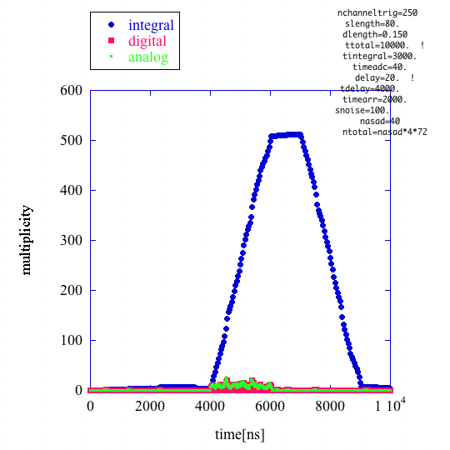
figure 1

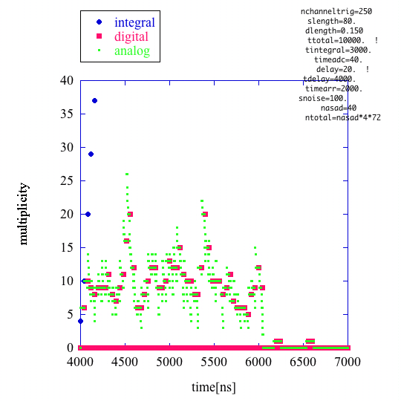
figure 2
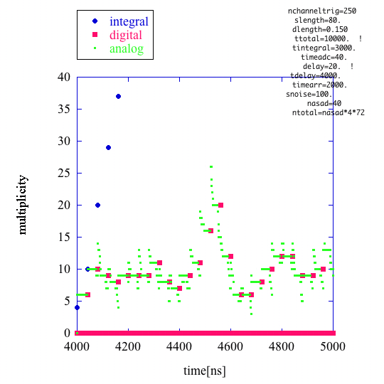
figure 3
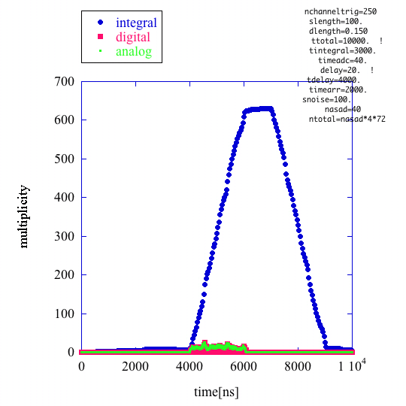
figure 4
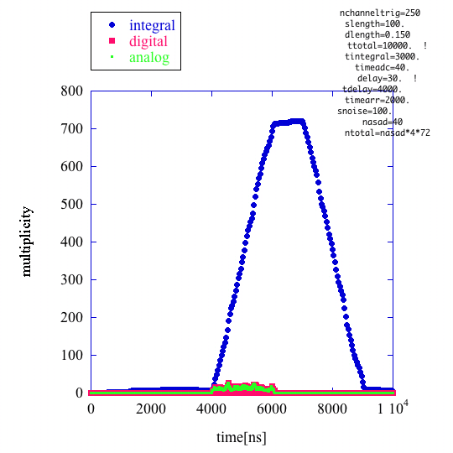
figure 5

Annex 1:Architecture of the trigger on the level of the AGET asic
P.Baron, 17th oct 2008

The requirements for the trigger have been defined after several discussions in the summer 2008, and were the following:
  - To deliver an analogical sum of the 72 discriminator outputs.
  - The length of the individual signal must be short (fixed to 100 ns or multiple of SCA write clock period).
  - These pulses will be synchronous with the SCA write clock period.
Today, the discussions on Triggering first level have introduced a new feature which is that the discriminators should have an adjustable dead time (0.5-3µs for example, to be discussed), to avoid multiple firing. A fixed length of 100 ns is recommended as previously for the 72 discriminator outputs but with the possibility to reduce it to 50 ns (by Slow Control, for example).
This new feature and the width of the trigger signal have also two possible analogical and digital solutions.
The digital solution.
As the frequency of SCA write clock is not fix (100 MHz) and can go from 1 MHz to 100 MHz, it will be difficult or not easy to realize 50 ns or 100 ns if we work at 1 MHz for example. The (only?) solution is to use the ADC clock which is in fact the best signal because the duration must be in fact a multiple of this clock (and not exactly of the SCA write clock).
The length of the adjustable dead time implies an individual timer proportional to the clock frequency. If we use the SCA write clock, we can see that we have the same problematic as before according to the value of this clock. By taking the ADC clock (25 MHz), it becomes more realistic but the depth of the counter should be at least 7 bits if a value of 3 µs is chosen.
The advantage is to have an adjustment independent of the SCA write clock, synchronous to the ADC clock.
The drawback is to introduce 2 additional pads on the circuit and to have another clock signal inside the chip. It increases also the silicon area (for the dead time) and digital noise.
The analogical solution.
The duration and dead time can be achieved by using 2 Monostables (voltage ramp + comparator) per channel: one for the 100 ns (or 50 ns) and the other for the dead time (range between 500 ns & 3 µs). To obtain the expected value, we need slow control to select the time range and to control the absolute value (+/- 15 % on the slope of the voltage ramp or threshold values). For the trigger width, 3 bits can be taken (2 bits for adjustment of the value at +/- 15%; 1 bit for double the range 50 ns to 100ns). For the dead time, the range can be adjusted by an internal DAC of n bits, common to all channels. This DAC can be used for the ramp or threshold voltage.
The advantage of this solution is to minimize the digital noise (any counter) and to avoid another clock signal.
The drawback is the level of adjustment which is analogical, independent of the ADC clock.

Conclusion:
Two solutions exist for the trigger requirements. The analogical solution seems to be the best.

Question about the output dynamic of the trigger signal.
The trigger signal is the analog sum of the 72 discriminator outputs. This implies that we must be able to detect a multiplicity of 1 to 72? Or only 1 to m levels?
Annexe 2: fortran program
program trigger1level
dimension atime(50000) !analogical sum as function of time coordinate
dimension dtime(50000) !logical sum as function of time coordinate
dimension slidtime(50000) !sliding time integration
dimension starttime(1000) ! start time for the trigger
dimension stoptime(1000) ! start time for the trigger
do i=1,50000
atime(i)=0. !analogical sum as function of time coordinate
dtime(i) =0. !logical sum as function of time coordinate
slidtime(i)=0.
c starttime(i)=0.
c stoptime(i)=0.
enddo
open( unit=9,file='trigger.out',status='UNKNOWN')
write(*,*)' begin'
nchanneltrig=250 !number of channels supposed to trigger
slength=100. !lenght of analogical signal ns
dlength=0.150 !fluctuation in % /100=relative
ttotal=10000. !total time under consideration
tintegral=3000. !integration time
timeadc=40. !clock time ADC
delay=20. !delay of the input from GET to the ADC
tdelay=4000. !delay of arrival
timearr=2000. !time dispersion of arrival
snoise=100. !noise triggers for each channel cts/s
nasad=40 !number 0f asad ntotal=nasad*4*72
ntotal=nasad*4*72
write(9,*)' total number of channels', ntotal
write(9,*)' event tstart tstop'
do it=1,nchanneltrig
c it is supposed that the trigger signal is synchronised with the ADC clock
int1=tdelay/timeadc !number of periods of ADC before arrival
dtt=rand(0)*timearr !uniformely distributed in tarrival
int2=dtt/timeadc !supposed to be synchronised by adc clock

starttime(it)=int1*timeadc +int2*timeadc
stoptime(it)=starttime(it)+slength*(1+dlength*2.*(0.5-rand(0)))
write(9,100)it,starttime(it),stoptime(it)
enddo
c add noise
nrand=snoise*ntotal*1.e-9*ttotal !random coinc during the total interval
write(9,*)' nrand=',nrand
if(nrand.ge.1)then
do ir=1,nrand
ind=ir+nchanneltrig
int1=ttotal/timeadc
starttime(ind)=int1*rand(0)*timeadc
stoptime(ind)=starttime(ind)+slength*(1+dlength*(1.-2.*rand(0)))
write(9,100)ir,starttime(ir),stoptime(ir)
enddo

else
endif
ntrig=nchanneltrig+nrand
c end of trigger signal definition
c define analog signal
itt=ttotal
itstep=timeadc
iprint=0
c write(9,*)' itt',itt
do itime=1,itt
time=itime
do j=1,ntrig
if(starttime(j).lt.time.and.stoptime(j).gt.time) then
atime(itime)=atime(itime)+1.
iprint=iprint+1
c if(iprint.lt.1000)write(9,*)'atime',atime(itime)
else
endif
enddo
enddo
do ipr=1,5000
c write(9,*)'atime ir',ipr, atime(ipr)
enddo
c this is the analogical signal, not separated for each ASAD
iprint=0.
do itime=1,itt,itstep
iconvert=itime-delay
c write(9,*)'boucle dtime'
if(iconvert.gt.0)then
dtime(itime)=atime(iconvert)
iprint=iprint+1
c if(iprint.lt.1000)write(9,*)'dtime',itime,dtime(itime),
c $ atime(iconvert)

else
endif
enddo
c define sliding time integral
idint=tintegral/timeadc !cycles of adc clock for integration

do itime=1,itt,itstep
itimebegin=itime-itstep*idint
substract=0.
if(itimebegin.gt.0) then
substract=dtime(itimebegin)
else
endif
add=0.
if((itime-itstep).gt.0)then
add=slidtime(itime-itstep)
else
endif
an=0.
if(iconvert.gt.0)an=dtime(itime)
slidtime(itime)=add+an-substract
c write(9,100)itime,slidtime(itime),dtime(itime),atime(itime)
enddo
100 format(i6,5f8.1)
write(9,*)' time integral digital analog'
do itime=1,itt
write(9,100)itime,slidtime(itime),dtime(itime),atime(itime)
enddo

stop
end

