Trigger for a TPC with After+ electronics
W.Mittig, 3rd july 2008

After+ and trigger
As reminder of the functioning of the After+ electronics, I remind the slights shown by Pascal Baron at Bordeaux (http://indico.in2p3.fr/contributionDisplay.py?contribId=16&confId=901).
I re-used some of them below. As was discussed at Bordeaux, the discriminator output should have an adjustable length, programmable , and have an auto-reset at the end of this time. A more detailed point that was mentioned at Bordeaux, was that each new discriminator-out signal should restart this time. This is illustrated on the figure 1 below.
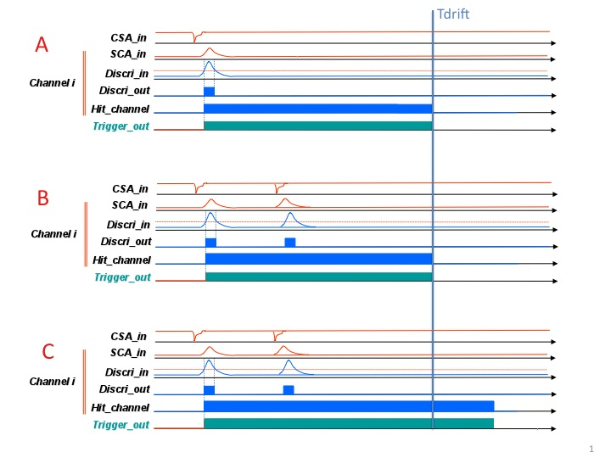

figure 1: Trigger output and hit channel register setting. Case A: a single event case; the length of the output is set to correspond to the maximum drift-time. The reset is internal at the end of this time. Case B: multiple hit event, without internal reset of the length. Case C: multiple hit event, with reset of the start.

As can be seen on the figure, in the case of a double hit in the pad i, if the first one is a random one and only the second one a “good”, one may loose the contribution of this pad in the multiplicity decision. Orders of magnitude: suppose an extreme total of 10⁵ events/second are seen by the TPC. Suppose an occupation of 2%, this is 2.10³ hits/s for each pad. With a drift-time of 50µs, the random hit probability for two uncorrelated events is 100.10^{3.}10⁻⁶=0.1=10%. This means the multiplicity as given by the sum of the trigger out, may be affected by the order of 10%. An exact estimation is somewhat complicated, because the loss of real multiplicity is somewhat compensated by randoms. The multiplicity of this type of event is (using 2% and 10⁴ channels) is 200 and probably the events selected will be the most central collision with an occupation of at least 2 times more, this is 400. If the hit register is used for selective read-out, the random double hits may be lost.
In the case of low multiplicity and with exotic beams, the rate and the occupation is much lower, and hence the influence of such an effect much lower. In the case C, with reset of the length at a new hit, a new problem may arise, if, as commonly is the case, the discriminator will give a multiple signal after a real pulse (ringing).

Proposal 1: There will be no reset of the start of the “trigger out” or “hit register” for multiple hit events in the same channel.

In the figure below is given the scheme of P.Baron, with the intoduction of an internal reset of the “trigger out” and “hit register”. For clearness, below 2 cases, one without valid trigger, and the other with valid trigger. Note modifications with respect to the version of P/Baron, concerning the reset of “hit “ register and “trigger out”.

Question 1: Check of this logic scheme concerning the hit channel register and trigger out is correct/convenient for you.

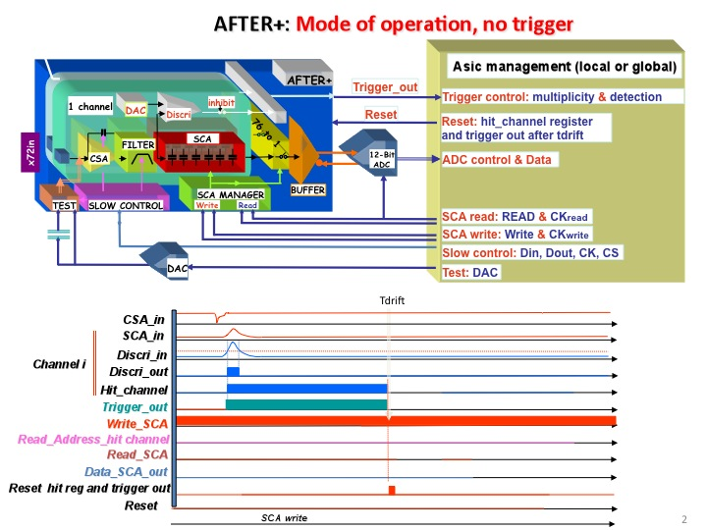

figure 2: mode of operation, no trigger; note change in reset of hit channel and trigger out with respect to the version of P.Baron at Bordeaux. A new reset is introduced in the lower part.

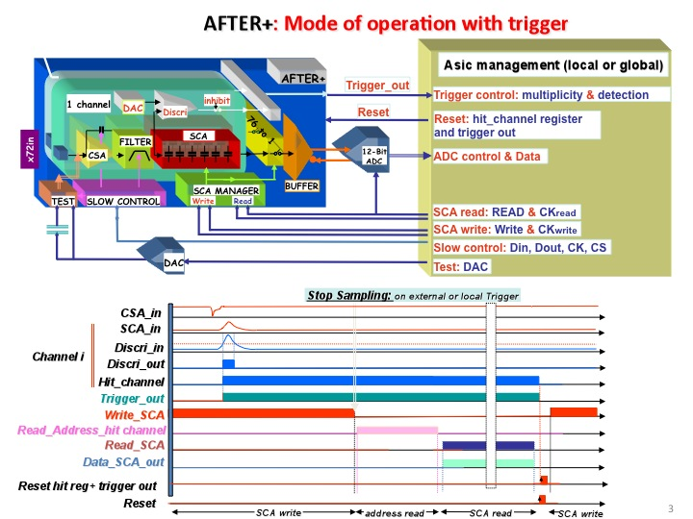

figure 3: mode of operation, with trigger; note change in reset of hit channel and trigger out with respect to the version of P.Baron at Bordeaux. A new reset is introduced in the lower part for the hit register and the trigger out. With respect to figure 2, it supposes that the internal reset at Tdrift is inhibited if there is a trigger signal, that stops the SCA write.

Trigger

We will here consider 3 trigger situations:
- An external detector gives the first trigger level
- The AT-TPC signals are used for the trigger
- Delayed implantation-decay experiment

Question 2: is the list of trigger situations complete?

Ad 1) An external detector gives the first trigger level

We will suppose that the external detectors have a timing that is fast as compared to the drift time of a TPC, such as scintillators, silicium detectors. The TPC information will then be used as a 2nd level trigger. For the general data acquisition structure, two cases may be distinguished: a) the drift-time is comparable to standard ADC holding time; b) the drift-time is comparable to standard ADC holding time. For standard gases such as isobuthane and P10, drift-times are of the order of 5cm/µs. For a 1m drift-space, this corresponds to 20µs. For H2 at 1atm, the drift-times will become long: drift velocity is 0.4cm/µs at 7kV/1m, and 1cm/µs at 70kV/cm approximately. Thus drift-times are in the range of 100-200µs. This is probably too long for keeping ADCs in a hold situation, and perhaps most convenient would be to treat this by independent data acquisitions with time-stamping.

The decision could be done in the following way(figure 4)
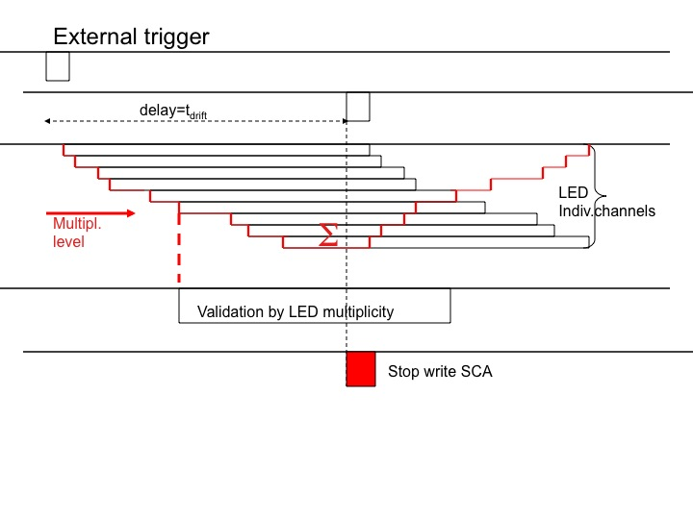
figure 4: Trigger logic with external trigger. The external trigger produces a pulse delayed by Tdrift. The analogigal sum of the individual “trigger out” signals is compared to a threshold, and gives a pulse of length Tdrift. The coincidence between the 2 pulses will provide the “stop write SCA” and initiate the read-out phase of the After+ (see figure 3).

Other more complicated decisions, such as choosing a multiplicity window, or making more complicated decisions (see below), as long as they are fast compared to Tdrift, can follow the same logic scheme.

Ad 2) The AT-TPC signals are used for the trigger

If no external detector is used, or the particles of interest do not leave the AT-TPC, one has to use the internal information of the AT-TPC. The use of the sum of the individual “trigger out” signals is illustrated on figure 5). We will call this “trigger-TPC” for shortness.
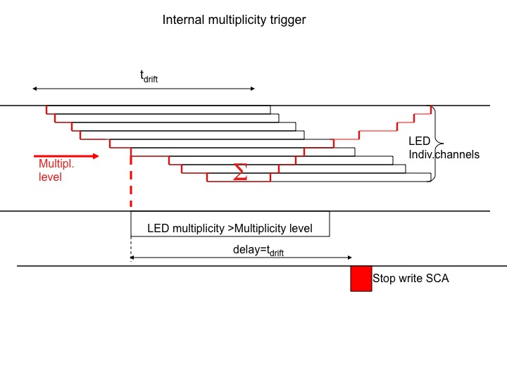
Figure 5: Trigger produced by the TPC. The analogical sum of the individual “trigger out” signals is compared to a threshold, and gives a pulse delayed by Tdrift, that will produce the “stop write SCA” signal and initiate the readout out phase (see figure 3).

As can be seen from this figure 5, the range of the SCA memory must cover now 2*Tdrift: because the signal is delayed by Tdrift, and may come with a delay between zero and Tdrift after the begin of the event, 2*Tdrift must be covered. This implies a specific difficulty: if the hit pattern is used for a selective readout, the hit-channel register may have reset internally (in the logic proposed). The most evident solution is just to program the delay of the internal reset of the “trigger out” and the “hit channel” to 2*Tdrift. The external delay(figure 5) will remain at Tdrift. The only inconvenience is a two times higher random pile-up in the sum signal. Order of magnitude: suppose 1000cts/s (beam region excluded, maximum data acquisition rate), and Tdrift=50µs. Then P=50*10⁻³=5%. Doubling to the possible random coincidence rate to 2*Tdrift, will result in 10%. Note that this difference of random rate only affects the pile-up in the sum of “trigger out”.

Proposition 2: In the case of “trigger-TPC” and the use of the “hit channel” for selective read-out, the delay of internal reset may be 2*Tdrift.

Ad 3) Delayed implantation-decay experiment

The 2p decay is a typical case of this type. Hence this section should be carefully read by the Bordeaux participants. One can consider that this case is a sequence of the case 1 (external trigger) followed by case 2 (trigger TPC). The first phase is fully illustrated by the figure 3 and figure 5. We can decompose
- from beam detectors an external trigger is produced, and a long window for blocking of beam and waiting for decay (“decay window”); internal reset-times of “hit” and “trigger out” must be set at 2*Tdrift to be compatible with next phase
- after Tdrift (about 10µs?) the “SCA stop write” signal is produced, without other condition
- a selective readout of the SCA is done (for evaluation see slight xx of P.Baron, will depend on optimized layout of FEC/beamparticles to have the lowest possible hit-density/FEC); 100µs??? (would correspond to about 2000buckets/FEC)
- as soon as the SCA read-out is finished, the After+ may receive a “SCA write” signal, (see figure 3), while the FEM transfers the data to the DAQ. This means the deadtime after implantation is of the order of 150µs(???)
- during the decay window, the sum of “trigger out” signals is compared to a threshold;

- if it is above threshold, a signal “stop write SCA” will be produced, as in figure 5

- transfer of data to FEM and DAQ

- ready for next event

This type of procedure implies a more precise knowledge of the relative situation of the FEC and the FEM. In a standard event, we can suppose that the “start write SCA” is delivered by the FEM (or the DAQ) at the end of a full transfer of the data. This is not part of the Trigger, but, strictly speaking, of a validation of trigger signals.

Question 3: is the description of the implantation decay scenario correct? What are more precise needs and estimations (Bordeaux)

Question 4: who produces the “end of event” in general?
(G. Wittwer, N.Usher?)

Question 5: how it will be possible to condition the “SCA write” by the end of transfer FEC-FEM? (G. Wittwer, N.Usher?)

Multiplicity box and “trigger out” signals

Typically, there will be of the order 4*40 After+, each with 72 channels; there will be one sum of “trigger out” per After+; these can be regrouped on the FEC
Question: One sum of “trigger out” per FEC or one sum of “trigger out” per After+?
Proposition : one sum of “trigger out” per FEC; in a first version of the Multiplicity box, a global sum of “trigger out” will be given. In later version the about 4o FEC signals may be analysed in more complex way (multiplicity/FEC,…)
There was a question related to eventual dead-time problems: is there a use of very short “trigger out” signals? This could eventually decrease deadtime problems, and allow other types of multiplicity detection (as for example neutron multiplicity in the Orion detector). Eventual problems may be multiple signals/channels, and channels that are noisy that will create wrong multiplicities. This is much less severe with the long signals: in this case a noisy channel may give at maximum multiplicity 1. And the dead-time of a TPC is in any case one drift-time, even if by intelligent (and complicated) analysis it is possible to eliminate traces from random events. I would resume the question in the following way:

Question 6: what is the minimum width of “trigger out”?

Remember the other questions by P.Baron on his slight 9.

Resumé

I suggest that for each project, there is one person who should enter the discussion as local contact, and the present (and following on this subject) document will be sent to the following persons:
Riken/Kyoto: Tetsuya Murakami
Ganil: R. Raabe
MSU: W.Mittig (coord)
Bordeaux: B.Blank
Saclay: E. Pollacco
GB: R. Lemmon
Engineers: G.Wittwer(Ganil), N.Usher (MSU) , P.Baron(Saclay)
The same document will be put on the wiki-site.
In the texte above, there are questions and propositions, I suggest you to copy the text below and insert your answers and opinons.

A general question to answer is:

Question 0a: are there important points omitted or wrong?

Question 0b: is the definition of what is the Trigger convenient (separation from DAQ, master trigger conception,…)?

Question 1: Check of this logic scheme concerning the hit channel register and trigger out (fig 2-3) is correct/convenient for you.
Question 3: is the description of the implantation decay scenario correct? What are more precise needs and estimations (Bordeaux)

Question 4: who produces the “end of event” in general?
(G. Wittwer, N.Usher?)

Question 5: how it will be possible to condition the “SCA write” by the end of transfer FEC-FEM? (G. Wittwer, N.Usher?)

Question 2: is the list of trigger situations complete?

Question 6: what is the minimum width of “trigger out”?

Proposal 1: There will be no reset of the start of the “trigger out” or “hit register” for multiple hit events in the same channel.

Proposition 2: In the case of “trigger-TPC” and the use of the “hit channel” for selective read-out, the delay of internal reset may be 2*Tdrift.

