Requirements, constraints and proposed solutions:

The aim is to design and build the electronic device that, within GET, will manage the multiplicity, the conditions for the trigger, the absolute time reference and the distribution of the clock signal over the whole system.

A particular attention to these aspects is due in a system destined to be coupled to the new generation of nuclear physics detectors. At up to 30 000 channels, the traditional techniques of “Trigger” used in nuclear physics (analysis-windows + sequencer) are not sufficient any more today in terms of functionality and of integration. One of the main challenges of this electronic is to achieve a counting rate of 1 KHz, so a maximum dead time of 1ms to process the event is allowed whatever the number of channels and the trigger configuration used.

This device is named “MUTANT” (MUltiplicity Trigger ANd Time).

In more detail, the main functions are summarized below. The MUTANT has to:

- Take into account a “level 0” trigger request with “accept/reject” decision, a “super-decision” coming from a local or remote (200-300m) external trigger (via the BEM card).

- Regroup the digital multiplicity at the highest level of the TPC;
- Choose the threshold of triggering and give the “level 1” trigger signal;

- Take a “level 2” decision on the fired bit pattern from the ASICs if level 1 is OK.

- Distribute a clock signal to synchronize all the elements (CoBo AsAd, and AGET);

- Manage a system of time-stamping to give, in each CoBo module, tags to the data, which will be sent to the acquisition computers. This allows, a posteriori, rebuilding the total event;

- Communicate with the external world via the Back End Module (BEM) essentially for “super trigger” and external clock (100/200 MHZ) synchronization aspects.

Global hardware considerations:

As explained in the CoBo CDR paragraph, the NIM (Nuclear Instrument Modules) form factor was first considered to house this new electronics. The NIM standard provides power supplies but no communication links between slots: this has to be created using cables. With a TPC able to provide up to 30 000 output channels, the problem of cabling becomes not negligible especially for the MUTANT-CoBo connections and for the individual CoBo network outputs. On the other hand, the possible use of parallel bus standards does not solve the problem of parallel communications (at the same time) between CoBo and MUTANT and between every CoBo and a network switch. This problem has been tackled by the new telecommunication architectures, mainly the Advanced Telecom Computing Architecture (ATCA) and recently the Micro Telecom Computing Architecture (µTCA). The idea is to collect or send data from a “TCA” switch to Advanced Mezzanines Cards (AMC) over carrier boards using a set of differential signals pairs routed as a star, a dual star or a mesh topology. All the specifications of these standards are defined and controlled by the PCI industrial Computers Manufacturing Group (PICMG).

Why using µTCA form factor:

Unlike ATCA, in a µTCA shelf the backplane is the unique carrier. The dual star carrier is used in telecommunications environment for redundancy in case of failure. One MicroTCA Carrier Hub (MCH1) can be connected to a maximum of 12 AMCs using the first set of starry signals while the second one (MCH2) use the other star to communicate with the same 12 AMCs. The “AMC.0” specification currently defines six form factors for AdvancedMC modules. The µTCA crate accepts 2 widths (Single and Double) and 3 heights (Compact, Mid-size and Full–size), all this based on a horizontal view of the AMCs.
The fact of the “dual star”, available now in a µTCA crate, fits perfectly with our nuclear physics application where we want to remove bundle of cables and where we don’t need redundancy. One star will be used for the MCH-CoBos connections (GbE) and the other star for the MUTANT-CoBo’s connections. This standard propose also 2 starry clock networks that will be very useful typically for the clock signal distribution from MUTANT to the CoBos.

The two boards (CoBo and MUTANT) equipped with what we call “an embedded system”, will be considered as AMCs even if the MUTANT board is in an MCH slot and has to control four “tongue connectors” in terms of signals to drive. The global management of the AMCs will be done by the MCMC (µTCA Carrier Manager Controller) of the MCH. In these telecom standards, the modules are also “hot-swappable”, one module can be switched on/off and inserted or removed while the status of the remaining system does not change. All these management functions are ensured, at the other end, by a Module Management Controller (MMC), which must be embedded on every AMC (CoBo and MUTANT).

Due to the size and the number of connectors that we need on CoBo and MUTANT boards, the form factor retained for GET is the Double Full-size version that offers the maximum space on the front panel. Taking into account this module form factor, a full µTCA shelf, composed of fourteen slots, will be equipped with: 1 or 2 Power Module (PM), 1 MCH, 10 CoBos and 1 MUTANT. As a consequence, a MUTANT device will have to control 10 Cobos in its own crate, adding up to: 10 * 4 ASAD’s * 4 AGET * 64 channels = 10240 channels.

As this new data acquisition architecture has to control up to 30 000 channels and that the constraint is to do that with no extra board, the idea is to have a versatile MUTANT that could be master of the system or simply slave, just configurable by slow-control with no hardware modification. In this case one master MUTANT, plugged in one shelf, will be the maestro controlling, in addition of its own crate, two other parallel branches (µTCA shelves) via slave MUTANTs. Based on 10 CoBos in each µTCA crate, this gives a total of 3*10240 = 30720 channels. The setup and the data acquisition will be done over Gigabit Ethernet via standard TCP/IP and embedded Linux. Most of the signals will be carried over differential pairs using electrical standards such as LVDS, M-LVDS and LVPECL. The Xilinx VIRTEX 5 FXT programmable logic will be used for the FPGA implanted on the PCB.

One front panel optic transceiver will be used to ensure communications between the TPC DAQ (MUTANT) and other coupled DAQ via a Back End Module (BEM), this essentially to receive a master clock from this external facility and a “super decision” in terms of trigger (L0). The use of fibers guarantees the transmission of clock and high speed signals (trigger request, trigger validation…) over 200 or 300 meters.

Clock distribution:

In terms of clock distribution, it is important to synchronize a maximum of operations from a unique clock source especially when you want to minimize de Jitter and control the Skew. If you use more than one clock domain for critical signals, you lose timing accuracy depending of the resynchronization clock period. Another point, in terms of ElectroMagnetic Compatibility (EMC), is that the more you introduce clock sources in your system, the more it becomes difficult to identify and remove perturbations on low level signals.

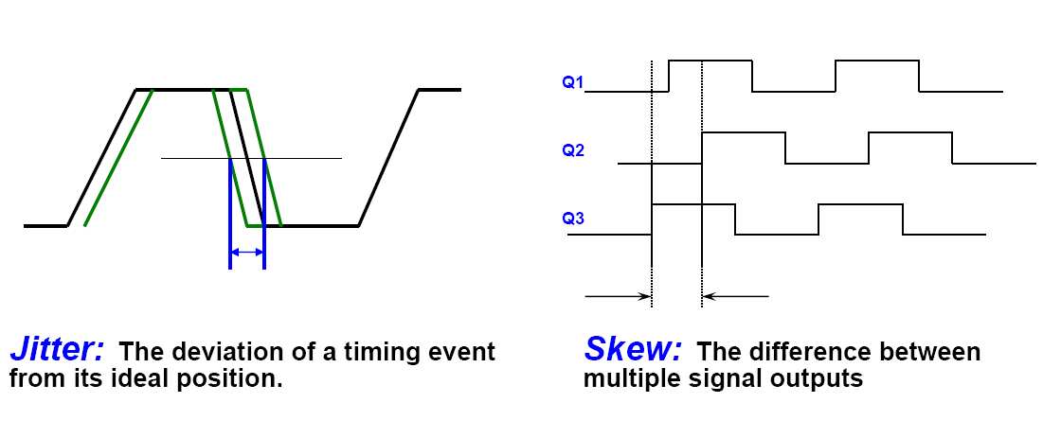
For the GET project, every AGET could have a sampling rate varying from 1MHz to 100 MHz. Even if this fact requires local dividers, all them programmed with the same value, it is important to propagate a common clock source to every AGET to be sure that every analog memory is fulfilled from the same starting point (same frequency, same edge) and stopped synchronously. A differential clock signal of 100 MHz will be distributed from the MUTANT to the ten CoBos in a shelf, using a star topology, all this with a skew below 1 ns. An extra differential signal using the same topology will distinguish between the sampling phase and the other phases (trigger decision in progress, readout or acquisition stopped). This will permit to start or stop all the AGETs synchronously to the master clock. These same signals will be replicated, to be sent to the two slave µTCA branches. The goal is to have a set of 2 signals, phase controlled, available for 30 CoBos. This also largely simplifies all the data transfers between the different boards that are synchronized with this master clock. The last point, about a global reference clock, is that most of FPGA manufacturers recommend a “synchronous design methodology” attached to the same clock as much as possible. But these clock distribution requirements must be maintained not only from MUTANT to CoBo but along the whole chain. Typically CoBo and ASAD designs must control theirs clock buffer paths, cable length and so on. A basic possibility, on an electronic project like GET, could be:
- The use of the global master clock (100 MHz), with clock dividers and jitter cleaner if necessary (i.e. division by 4 for the 25 MHz of AGET), everywhere when timing relationship, data transfers between boards are necessary. It also simplifies the calculation of the total time required to process an event when summing the multiple phases (more deterministic).
- The use of only one additional local oscillator on the board, dedicated to the processor (PPC440) and, for example, the network application, that permits to keep communications healthy (slow control, monitoring…) even if the global master clock is missing for any reasons (not set up, broken buffer…).

Typical clock tree:

Clock Phase/Edge Alignments:

In such architecture, even if the Global Master Clock is well distributed between µTCA shelves, it is important to have the possibility to check the phase (i.e. edge) of the write clock (CKW) at the very front end, typically at the ASAD level. The idea of a box taking into account one or two multiplexed ASAD output signals could be the best way to analyze phase shifting between ASAD clocks due to their own individual path (cable length, connectors, buffers …). This will give an independent view of the cabling used for the experiment. This same box, acting as a big multiplexer closed to the detector, could be used also during the experiment for debug purposes or to check less critical signals. This spy box driven by slow control could be designed around an FPGA kit in order to minimize the hardware/software development time. An embedded (automated) “time delay” measurement and few outputs (for oscilloscope) can simply solve the problem of clock phase matching and signal integrity.

MUTANT Parameters | Value/Comments
Global Master Clock
Frequency | 100 MHz
Skew | < 1ns
Source | Internal if master MUTANT (F=200 MHz/Jitter=10ps RMS) or External (Local or remote via BEM)
Trigger Levels
L0 | External with time window and trigger request/validation signals (local or remote via BEM)
L1 | TPC Digital Multiplicity with min/max thresholds
L2 | Hit pattern with or without selective pattern readout and fast reject option
Event tagging
Time stamp | 48 bits /10 ns (more than one month of experiment)
Event number | 32 bits (more than one month of experiment @ a counting rate of 1KHz )
Acquisition Modes
Common Dead Time | Time stamp and/or Event Number
Autonomous | Time stamp only - Free running CoBo’s
Master/Slaves
Number of branches | 2
M/S distance | 2 or 3 meters
Communication
Network | GbE with TCP/IP protocol for slow control and data readout
Operating System | Embedded LINUX
Processor | PPC 440 (Xilinx Virtex 5)

