Insert for part III:

When a source is put at the center of the bar, one expects, based on symmetry, the following:
- The time that it takes for the light to travel to each end of the bar must be equal and assuming that the two phototubes are identical, the time to generate a pulse as well. Hence, as one triggers on channel 1, the signal from channel 2 should appear at the same time as that of channel one. At the same time, the pulse heights registered on each side of the bar are expected to be the same as well, if one assumes that equal amounts of photons go left and right.
- What you observed probably looked something like shown in Fig. 5. Channel 1 is the trigger, and, as expected, the signals from channel two comes in at (nearly) one fixed point in time (compare with Fig. 4). However, the peak of channel 2 is shifted in time relative to that of peak one (in Fig. 5 it appears to come earlier). A possible reason is the difference in cable length used for the two signals coming from the tubes, or other small delays in the circuit. One could correct for this by adjusting cable lengths. However, since the shift just corresponds to an offset, which can easily be corrected for when analyzing the data, it is not so important.
- To look at the relative pulse height, it is easier to look at some single snapshots (like in Fig. 5b), so that you can compare signals that certainly belonged to the same event. If you look closely at several snapshots, you will see that the pulse heights of the two signals are indeed strongly correlated. Actually, it would be better to compare the surfaces under the peaks since that corresponds to the charge collected in the phototube (the pulse height is still a good measure for the amount of charge collected if the pulse shapes coming from the two tubes are similar). Of course there are some deviations; on an event-by-event basis, a little more light might leak away on the left than on the right side, or vice versa.
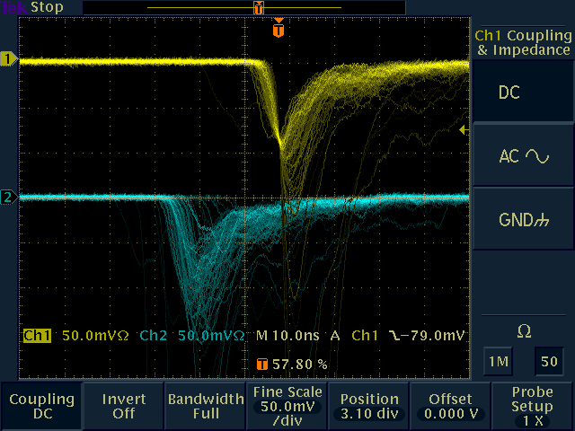
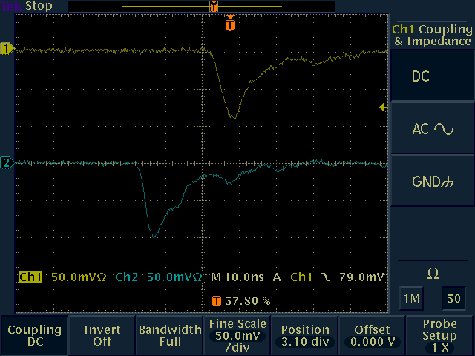
Figure 5. Signals from the left and right phototubes when a source is placed at the center. On the left hand side events come in continuously. On the right, a snapshot from a single event is shown.

Insert 1 for part IV

In Fig. 6 the signals as seen on the oscilloscope when the source is placed on the left side of the bar are shown. Two things can be observed.
- Relative to the situation where the source was placed at the center, the signals from channel 2 appear to have shifted in time relative to those of channel 1.
- The signals in channel 2 have a reduced peak height, relative to those in channel 1. This indicated that the channel one (yellow) corresponds to the phototube attached to the left side of the scintillator bar.
- Since it takes longer for the light to travel to the right side of the bar, the signals in channel 2 (blue) are delayed relative to the situation where the source was at the center (compare with Fig. 5).
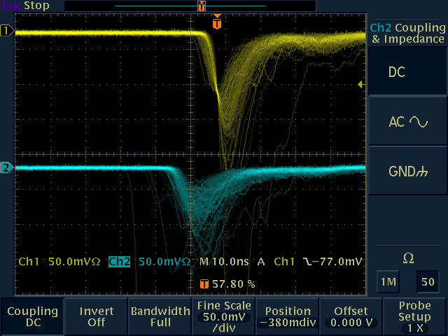
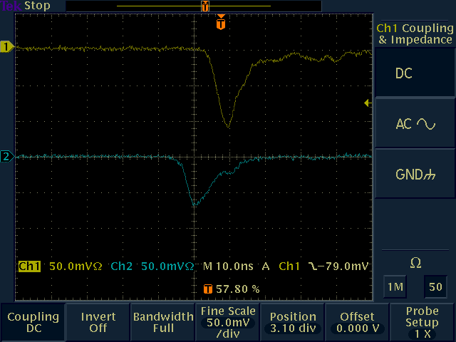
Figure 6 Signals from the left and right phototubes when a source is placed on the left. On the left hand side events come in continuously. On the right, a snapshot from a single event is shown.

Insert 2 for part IV

In Fig. 7 the signals as seen on the oscilloscope when the source is placed on the right side of the bar are shown. Two things can be observed.
- Relative to the situation where the source was placed at the center, the signals from channel 2 appear to have shifted in time relative to those of channel 1.
- The signals in channel 2 have an increased peak height, relative to those in channel 1. This indicates that channel two (blue) corresponds to the phototube attached to the right side of the scintillator bar.
- Since it takes longer for the light to travel to the right side of the bar, the signals in channel 2 (blue) appear earlier in time relative to the situation where the source was at the center (compare with Fig. 5).
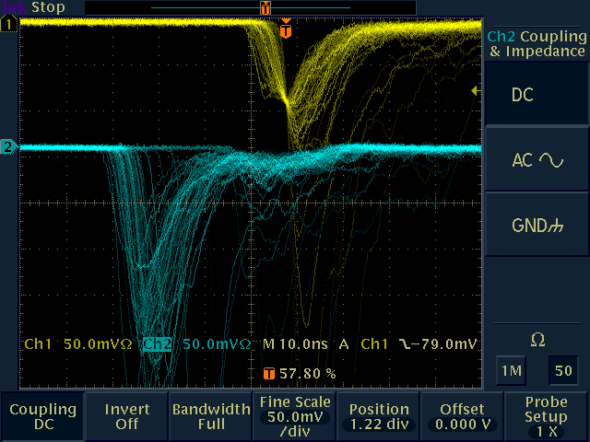
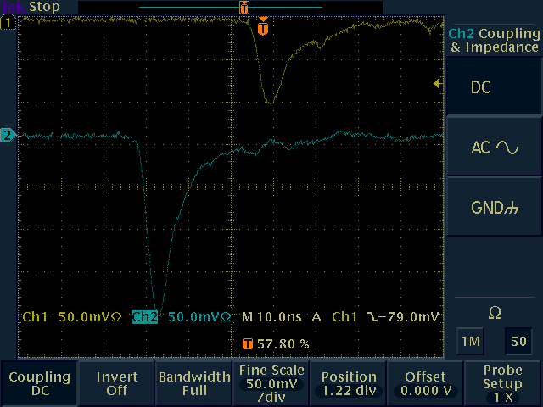
Figure 7 Signals from the left and right phototubes when a source is placed on the right. On the left hand side events come in continuously. On the right, a snapshot from a single event is shown.

