

cOsmIc rAy experiment

(with Real Nuclei from Outer Space!)

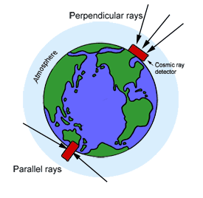
objective:
Figure 1 Cosmic rays approaching rectangles that represent the detectors
Find out how the frequency of cosmic ray events changes with the angle between the detector and the earth’s surface.

materials:
You Provide  Pencil or Pen  A partner | NSCL Provides  Cosmic Ray Detector  Protractor/Plumb bob  String  Supportive materials  Stopwatch  Calculator | Universe Provides  Cosmic Rays
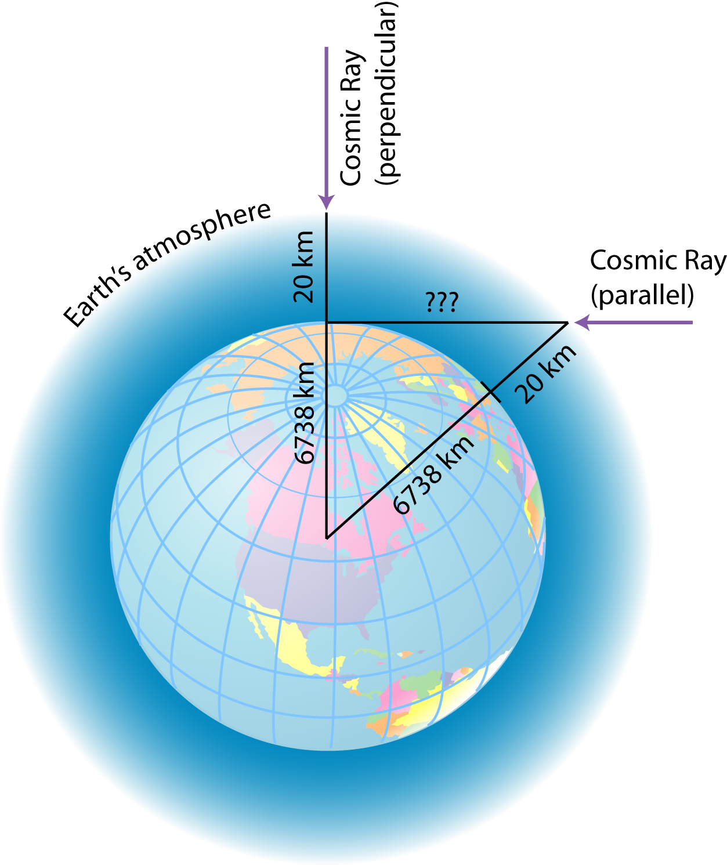
Consider This:
Before continuing to your prediction, think about how the atmosphere is affecting the cosmic rays. Rays approaching you perpendicular to the Earth’s surface must penetrate 20 km of atmosphere. When rays come towards you parallel to the Earth’s surface, calculate how much atmosphere they have to travel through. It’s a lot more! (Hint: study the diagram at right, and use the Pythagorean Theorem)

hypothesis:
Does the number of cosmic rays coming to you from space depend on whether they are traveling perpendicular to the surface (coming from above) or parallel (coming from the horizon)? How so?

prediction:
If you were to measure the number of cosmic rays coming in at different angles to the earth’s surface, based on your hypothesis, how do you think the angle will affect the cosmic ray count rates (specifically, how will the rates change as you vary from detecting perpendicular to parallel cosmic rays)?
operating the cosmic ray detector (CRD):

- Plug it in! You may need an extension cord. It should turn on immediately.

- There are four switches that you will be using.
  - Switch A, as shown in the diagram, controls the buzzer – whether or not the machine beeps every time it counts a ray.
  - Switch B controls what events the detector will report as a count. Do you want rays that hit the top scintillator, the bottom scintillator, or coincidence (both scintillators)?
  - Switch C controls the count mode. Do you want it to just keep counting without stopping (infinite), to count for one minute and then shut off (timed count), or stop counting while still displaying the current count (hold count)?
  - Switch D clears the count. Most of the time, D will be positioned on “count,” which lets the detector work, but sometimes you will turn the switch to clear and reset the count.

Figure 1) Controls of the cosmic ray detector

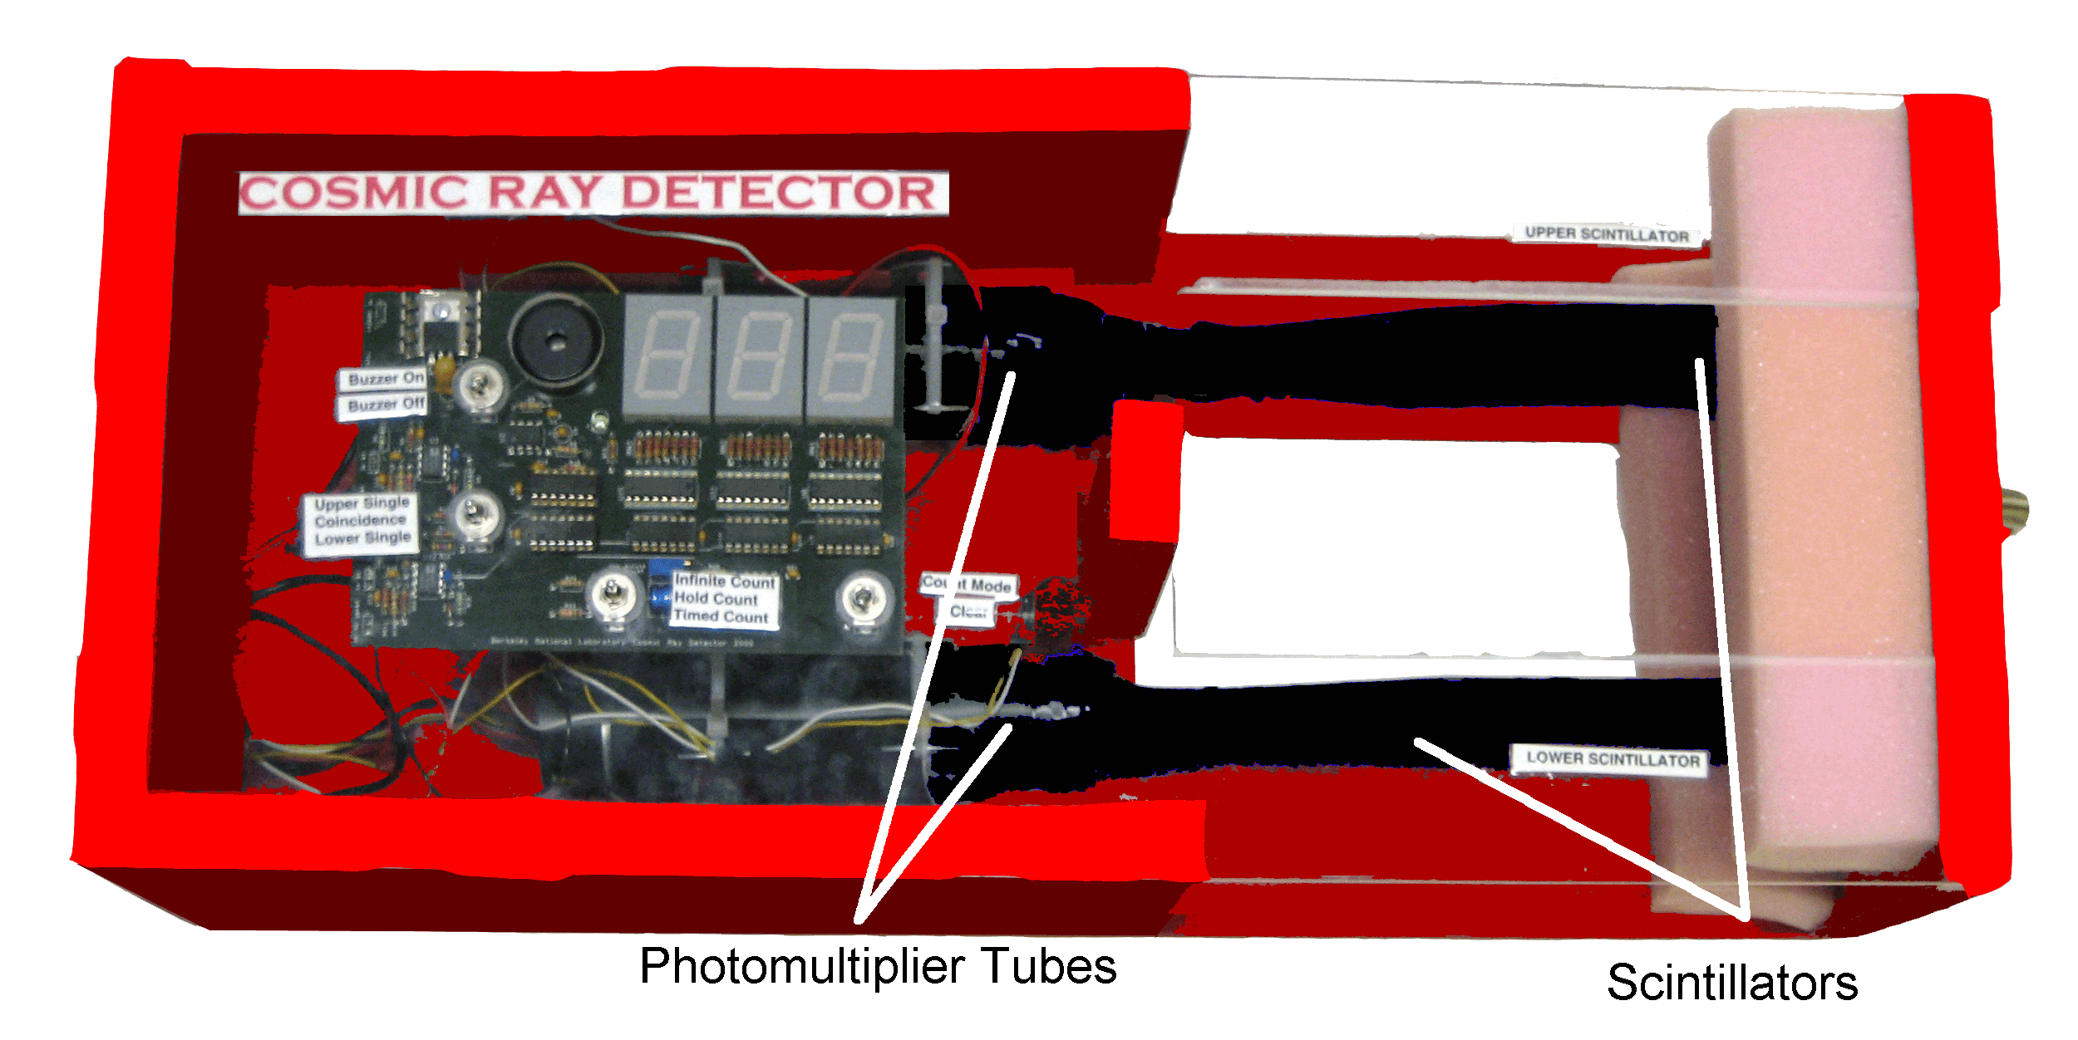
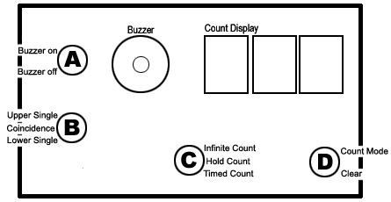

test the detector:

IF YOU ARE WITH A LARGE GROUP, YOU AND YOUR PARTNER MAY HAVE TO SHARE THE DETECTOR WITH ANOTHER PAIR OF STUDENTS.
If the detector fails to count at all or counts so fast the numbers read “888”, ask for help!

Upper Single

- Set the switches on the detector so that buzzer is turned off (Switch A) and ‘upper single’ hits (Switch B) are counted.
- Set the detector to “hold count” (Switch C).
- Clear the counts by moving switch D to “clear” and then moving it back to “count.”
- Switch the count mode to “infinite” while another person starts the stopwatch at exactly the same time.
- Let the cosmic ray detector count for 60 seconds. Each count represents a secondary cosmic ray (probably a muon) exciting an atom in the scintillator paddle, making it emit light.
- Immediately when the timer reaches 60 seconds, stop the timer and switch C to ‘hold count’.
- What is the reading on the display count of the detector? N= .

Lower Single

- After clearing the display of your detector, set the detector to “lower single” setting.
- Repeat steps 4-6.
- What is the reading on the display count of the detector? N= .

Coincidence

- After clearing the display of your detector, set the detector to “coincidence” setting.
- Repeat steps 4-6.
- What is the reading on the display count of the detector? N= .

A. Did the “coincidence” setting count considerably less than the “upper” and “lower” settings? Why?

B. What is the reason for using the “coincidence” setting in your experiment (think about what you are trying to measure, and how to do that accurately)?

experiment:
With a partner, test the angle of the cosmic ray detector in relation to the number of counts and record your findings in the chart below.

- Find a spot in the NSCL Atrium to set up your detector, including a surface to lean it against so you can try multiple angles.

- Set the switches on the cosmic ray detector so that coincidence events are counted (switch B). Set the switch C to “hold count.” Clear the counts by moving switch D to “clear” and then moving it back to “count.”

- Set the cosmic ray detector on its end (vertical position*) so that it catches rays coming in parallel to the earth’s surface (defined as 0 degrees). You will have to hold it in this position.

- Switch the count mode to “infinite” while starting the stopwatch at exactly the same time.

- Let the cosmic ray detector count for 180 seconds (3 minutes). Stop your watch and switch the count mode to “hold count” simultaneously. Record the count in the table on the next page under “0 degrees”.
While you are waiting for the detector to count, fill in the table on the next page by calculating the “count rate” and “error in count rate” as explained below the table. If you STILL have time, turn to page 8 to learn more about how the detector can identify the cosmic rays!

- Using the protractor, string, and plumb bob, set up your cosmic ray detector so that it is at an angle of 15 degrees from the ground. Support it with whatever material you have available: a wall, chair, etc.

- Switch C to “hold count”, and clear the count again by switching D to “clear” and back to “count”.

- Switch C back on “infinite count” while starting the stopwatch at the same time, again counting for 180 seconds.

- Repeat the process until you have recorded counts for 30˚, 45˚, 60˚, 75˚, and 90˚. At 90°, the detector should be catching rays perpendicular to the earth’s surface.

results:

DO THIS PART WITH YOUR ORIGINAL PARTNER

Angle of cosmic rays (degrees) | 0 | 15 | 30 | 45 | 60 | 75 | 90
Number of counts
Count Rate (counts/second)
Error in Count Rate
(calculated in Analysis section)

COUNT RATE:
In your table on the previous page, you have recorded the number of cosmic rays that struck the detector in a three-minute interval. Now find the count rate by dividing the N number of cosmic rays by t=180 seconds for each angle.

ERROR IN COUNT RATE:
Goals: Human and systematic errors affect how the data should be read. Because no measurement is absolutely precise, we include an error to provide range of accepted results. For example:

- Say one records N=540 hits over t=180 seconds, averaging at a rate of 3 counts per second.
- According to the formula below, the error will be 0.13 counts/second
- So, the actual result will read 3± 0.13counts/second. This is the accepted range that you will record for the trial.

The error is given by the following formula:
$σ_{\text{CR}}=\frac{\sqrt{N}}{t}$
- σ_{CR} is the error in count rate
- N is the number of counts
- t is the time (180 seconds).

Questions about your results:
  - Do your counts appear to change consistently as you change the angle of your detector? _________
  - If so, how are they changing? ___________________________________________
  - Does this match your prediction (pg 1)? _________
  - Does the count rate appear to change depending on whether your CRD is set up to detect rays that are coming in more perpendicular or parallel to the Earth’s surface? (this relates to your hypothesis on pg 1) _________
Next, you will do a statistical test to see if the data match your prediction, and thus either support or disprove your hypothesis.

significant difference?

At this point, scientists must be careful: while your data may appear to show a clear effect, just because one number is higher than another doesn’t necessarily mean anything. That’s because your data have error, which is basically some uncertainty in the value.

Example: In taking measurement A, you count 500 cosmic rays. | A  500  counts
You calculate that the error in your measurement was 100, so the real number of cosmic rays isn’t necessarily exactly 500, but is probably between 400 and 600 (500 +/- 100). | A  500  400 600  counts
Further example: you take measurement B with your CRD after changing something (angle, altitude, shielding, etc.). This time you measure 640 counts. That’s higher than measurement A’s 500, right? | A  500  400 600  640  B  counts
Looks like whatever you changed had a real effect. But the error in your new measurement is 110 counts. So how different are A and B really?  Measurement B: 640 +/- 110 → 530 – 750 CRs | A  500  400 600  640  B  530 750  counts
It’s possible that measurement A should be as high as 600, while B could be as low as 530. So while B is higher than A, you’ll notice that the ranges for A and B overlap when you include error: | A  500  400 600  640  B  530 750  counts

So is B higher than A? With these data, we can’t say for sure. Because their error ranges overlap, we say that A and B are not significantly different. With more data (longer count times!), you might find that there really is a difference. Now it’s time to see if there is a significant difference in your data by comparing the two most different conditions with the following calculations:

Measurement A: cosmic rays at 0 degrees  count rate: __________ error σ_{CR}: _____________  Range of values for measurement A:  A - σ_{CR} = ___________ to A + σ_{CR} = __________ | Measurement B: cosmic rays at 90 degrees  count rate: __________ error σ_{CR}: _____________  Range of values for measurement B:  B - σ_{CR} = ___________ to B + σ_{CR} = __________

Is there a significant difference between A and B (0 and 90 degrees)? (YES if the ranges DON’T overlap, NO if the ranges DO overlap) ________
analysis:
Did you find any significant difference in count rate between the angles 0 and 90 degrees?

Yes
No

Which angle had the higher count rate?

0 degrees 90 degrees
Would you guess that there’s no difference because the number of cosmic rays is pretty much the same at both angles, or because your errors were very large? ____________ ___________________________________

Why do you suppose that count rate is greater? (What are the effects of the atmosphere?) ________________________________________________________________________________________________________________________
Was your prediction (pg 1) correct?

Yes No

Based on that, do the data support your hypothesis (pg 1)? Why or why not?
_______________________________________________________________________________________________________________

Think about how you conducted your experiment and what factors may have influenced your data. Are you confident that your data are sufficient to prove or disprove your hypothesis?

Yes No

What factors may have contributed to your sources of error? List as many as you can.
Think: were there any factors that could affect your measurement? Detector, human input, environmental conditions… _________________________________________________________________________________________________________________________________________________________________________________________
If you were to try this experiment again, what would you do differently to minimize error?
__________________________________________________________________________________________________________________________________________________________________________________________________________________________________________

Nscl cOsmIc rAy experIment

How the detector works

A scintillator is a material that gives off light when struck with a charged particle, such as a nucleus. Believe it or not, the scintillators on the cosmic ray detector are made of plastic that has been mixed with special scintillating material. They are wrapped in layers of aluminum foil, construction paper, and finally the electrical tape that you see on the outside. When a cosmic ray strikes the plastic, it excites (or gives energy to) an electron in one of the atoms. The excited electron wants to give up its energy, so it emits a photon (you can think of it as a particle of light). This is an interaction. NSCL uses scintillators like these in many detectors.

Photons can come from other sources, like fluorescent bulbs and the sun. The electrical tape and construction paper are necessary to keep stray light from getting into the scintillator. This way, the only light in the scintillator is due to cosmic rays. The aluminum foil helps keep stray light out and reflects light from interactions with cosmic rays back into the scintillator. This light eventually (and by “eventually” I mean “in less than a microsecond”) bounces into the photomultiplier tube.
Inside the photomultiplier tube, the photon strikes an electron and gives it enough energy to leave its atom. Then, the negatively charged electron gets pulled toward a plate of positively charged metal. Once it hits the metal, it frees other electrons. These electrons hit the next piece of positively charged metal, which frees even more electrons. This process continues until there are around a million electrons. They strike the last metal plate, which registers the electrical signal as a single count. When a cosmic ray strikes the scintillator(s) and results in a count, we call it an event. NSCL detectors can use the timing, location, and frequency of events to learn about rare isotopes.

You’ll notice that the detector has two scintillators, not just one. This allows you to control the direction of the cosmic rays that you are counting. If you use only one scintillator, the cosmic rays may come from any direction. If you set the detector to “coincidence,” the detector will only count the rays that pass through both scintillators. The rays that it detects will come in at an angle roughly perpendicular to the scintillator paddles.

Figure 3 Shows scintillators and photomultiplier tubes of a detector similar to the one that you will use!

* For this experiment, the word horizontal refers to the detector when it is lying flat on the ground and vertical refers to the detector when it is standing on end. The directions of cosmic rays will always be identified as parallel or perpendicular to the earth’s surface.

