Detecting particles with the Modular Neutron Array (MoNA)

Introduction
The Modular Neutron Array MoNA is used to detect sub-atomic particles. Usually, in experiments carried out with this device at the NSCL, the goal is to detect neutrons. However, it is for example also sensitive to cosmic rays (e.g. muons). In the first part of your experiments with MoNA, you will use an oscilloscope to analyze signal from a signal scintillator bar and learn about some of the properties of the detector.

You will be working with a small group on these experiments. Remember that it is important to learn about all aspects of the measurements and the experiment. Like in experiments that are usually performed at the NSCL, group work is key. While you cannot specialize in all details of a measurement, you must keep track of all facets so that the various tasks are carried out in harmony. Discussion of the measurements, results and method between the members of your team is key to a successful experiment. Make sure not to focus on a single task: switch duties and explain to your team members what you have learned before.

Each MoNA bar is a plastic scintillator. When struck by a particle (for example a neutron), light is emitted. This process is called ‘scintillation’. The light travels through the bar and is amplified and converted in photomultipliers. The term suggests that the photons (light quanta) are multiplied, but this is not really true. When photons enter the photomultiplier they hit a photocathode where an electron is emitted via the photo-electric effect (see Fig. 1). By applying a high voltage, the electron is accelerated towards a set of dynodes. Each time an electron hits a dynode, it frees more electrons that in turn also accelerate and free further electron in the next dynode. At the end, the electrons are collected in an anode where a current is produced that can be measured and registered in, for example, a data acquisition (data collection) (DAQ) system. You will work with the DAQ system in the second part of the experiments.

When light hits a MoNA bar, many photons are created that can travel to either side of the bar (and some will get lost). On each end, a photomultiplier is attached so that the signal can be registered. (see Fig. 2) There are two important observables that can be used to learn something about the event (i.e. the hit in the scintillator):
- Timing: by looking at the difference between the arrival times of the signals on each end, one can deduce the hit location of particle.
- Charge: The amount of charge collected on each side will also give information about the hit location. The closer a particle hit near one end, the larger the signal, since more light can reach the photomultiplier.
You will use the oscilloscope to study both observables. You must first learn to operate the oscilloscope and familiarize yourself with the basic properties of the signals. It is important to keep a log-book, where you keep a record of everything you do and answer the questions given in this manual.

In Table I some helpful constants, equations and conversions are given. Please use units of meters and seconds (or derivations thereof as shown in the table) in your analysis.

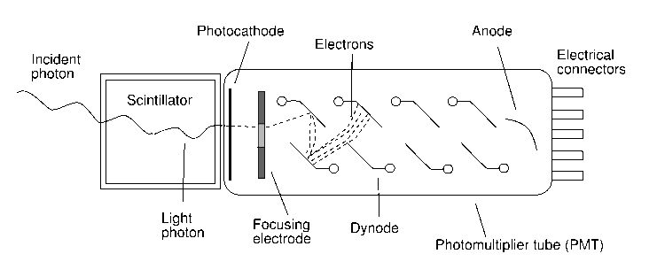
Figure 1. The basic operation of a photomultiplier, used to record light produced in the scintillator, amplify the signal by electron-multiplication and generate an electric current to can be used in the analysis.
oscilloscope
Figure 2. The basic layout of a signal MoNA bar. When a particle hits the MoNA bar, scintillation light is produced traveling to either side. The light is collected in photomultipliers. The electric signal from these photomultipliers can be displayed on the oscilloscope.
Table I.
c=3x10⁸ m/s (300000000 m/s) = 0.3 m/ns – speed of light in vacuum
v=c/n the speed of light (v) in a material with index of refraction (n) equals c/n
n_{scintillator}=1.5
1 m = 1000 mm (millimeter) = 1x10⁶ μm (micrometer)
1 s=1000 ms (millisecond)=1x10⁶ μs(microsecond)=1x10⁹ ns(nanosecond)=1x10¹² ps (picosecond)

SAFETY
During the experiments, safety ALWAYS comes first. The photomultipliers are operated under high voltage and you also have to work with some radioactive sources (these MUST be handled by the support staff). Please read carefully the safety instructions before starting the experiments and always follow the instructions of the support staff. In case you are not sure about something, ask. Never try out a procedure if you are not sure what the consequences will be. Don’t be afraid to tell someone to stop doing something if you think it might be unsafe. At the NSCL, we have a ‘stop-work’ policy which states that any person should stop immediately if told that his behavior is unsafe. We will follow that policy during the following experiments.

Part I: Familiarize yourself with the oscilloscope and basic signals from the detectors.
To start, you first need to understand the basic operation of the oscilloscope. You’ll be using a digital oscilloscope, which has many nice features that are helpful for understanding the signals from the photomultipliers. However, there are so many options that it is worthwhile to take a bit of time to familiarize yourself with the basic functions. The support staff will help you get set up.
- Make sure you understand how the cables are being connected to the oscilloscope. Since the PMT is operated under high voltage, the connections will be made by the support staff, but it is nevertheless important to know where the signals are coming from.
- What is the horizontal axis? How can you change the scale?
- What is the vertical axis? How can you change the scale?
- How can you move the signal left-right and up-down?
- What is the threshold (a.k.a. trigger-level) for accepting a signal? How can you change it?
- Try out the ‘RUN-STOP’ button and the ‘SINGLE SEQ’ button. What can they be used for?
- Why does the signal always start at the same point on the screen along the horizontal axis?
- After you have played around with the various functions and made sure you understood the basic operation, make a sketch of the signal in your logbook and try to interpret the signal. What are you actually looking at? Why does the signal height (or depth) vary? You may see two groups of signals with different heights. What are these events caused by? Does the rate of signal depend on pulse height or not, and why?
- The student helpers put a neutron source in front of the scintillators. What difference do you see on the oscilloscope compared to the previous measurement without the source? Pin down signals from neutron.

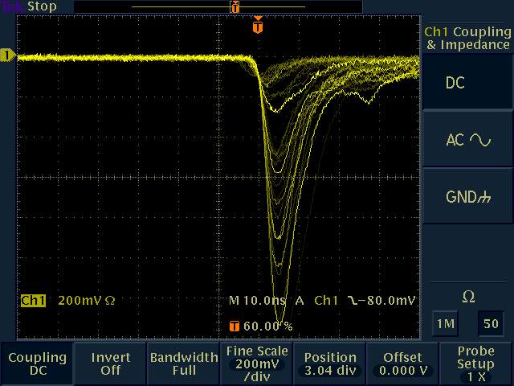
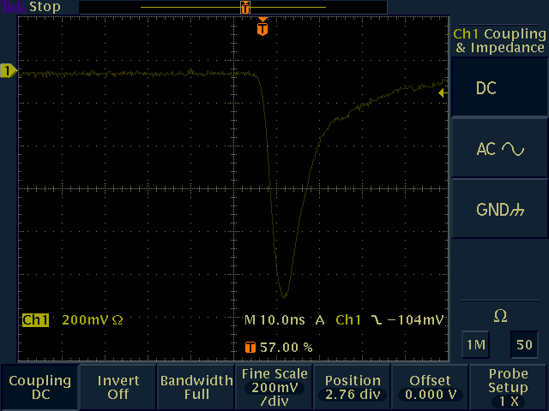
Figure 3 signal from a single photomultiplier tube on the oscilloscope. On the left, events come in continuously. On the right, the display is set to take a single event for close observation.

Part II: Make the full setup and learn to read the info from the oscilloscope.
Next, add the signal from the other phototube attached to your bar on the screen. Plug it in channel 2. Adjust the scaling for that channel so that both signals from the left and right phototube are visible and use the same x and y axis scaling. You will note that you have to switch channels when you want to manipulate the settings for the two independently. Before continuing, realize that channel 1 is your trigger channel; i.e. if a signal appears on the channel that is above threshold, it will display the signals in both channel 1 and channel 2. Of course, you can change this if you like, and make channel 2 the trigger. Assuming channel 1 is the trigger, the display on the oscilloscope should look something like in Fig. 4 (left). Take a careful look at this picture and try to understand what you see.
- Why does the other channel show signals that appear at different times? What is the meaning of these shifts?
- Take some snapshots and try to understand the meaning of the difference in pulse height for the two channels. What is the meaning of these differences?
- If instead of looking at two signals from phototubes attached to the end of the same bar, one would look at one signal from a phototube attached to one bar and another signal from a phototube attached to another bar, what would the oscilloscope show?

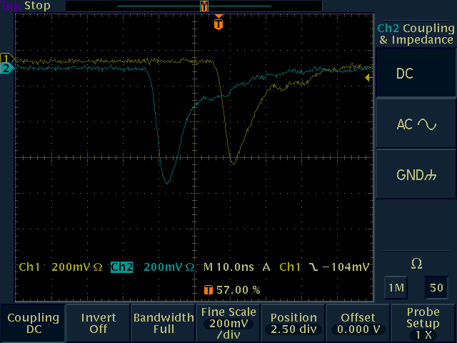
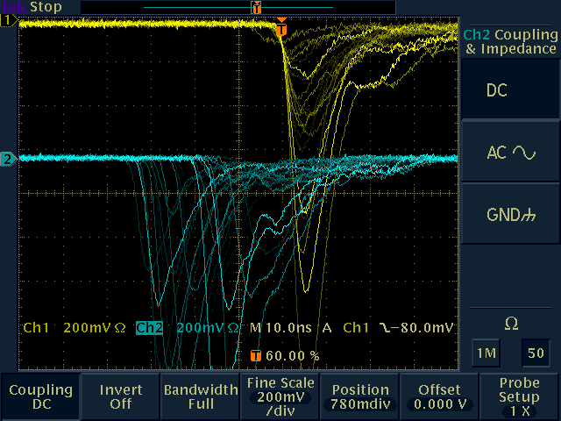
Figure 4 Signals from two photomultipliers attached to the same scintillator bar. On the left hand side events come in continuously. On the right, a snapshot from a single event is shown.

Part III: Position determination.
So far, we have been looking at events for which we do not know where the hit took place along the bar. Now we are going to change that by placing a source in front of the bar. The event rate due to this source will be much higher than due to the background (the events that you have been looking at until now) and we can ignore the latter. By using the source, we can determine what the response is of the scintillators as a function of the location of the source along the bar. First, the source is placed near the center of the bar, and the distance to the left and right phototubes is thus equally long. Before you look at the signals on the oscilloscope write down what you expect to see by answering the following questions.
- What do expect the relative difference in time to be for the two signals coming from the phototubes on either side of the bar?
- What would this look like on the oscilloscope?
- What do you expect the relative pulse height of the two signals from each phototube to be?
- How would this appear on the oscilloscope?
- Now look at the oscilloscope and check whether your expectations are confirmed. If not can you think of possible reasons why? And could you fix those issues? If so, discuss with the support staff and if possible, fix them. (Hint: what does the arrival time of the signal depend on, besides the travel time of the light through the scintillator?)
The support staff will give you a page with some sample pictures and explanations. You can add that page to this manual. Write down your conclusions in your logbook.

Insert for part III: Add here the page given to you by the support staff

Part IV: More on position determinations
Next, the source will be placed near the left side of the phototube. Before looking at the signals on the oscilloscope, predict what the signals from each side will look like:
- Compared to the situation where the source was placed at the center of the bar, what do you expect for the difference in timing for the two signals on each side of the bar? If you found that there was an offset in timing in part d) and did not correct for that, take it into account for your answer.
- Similarly, what do you expect for the relative pulse heights?
- Now check the signals on the oscilloscope and check whether your expectations are confirmed.
- Make sure to talk to one of the support staff. They will give you another insert for your manual. Write down your conclusions in your logbook.

Repeat this procedure with the source placed on the right side of the bar and answer the same questions. Again, check with the support staff; they will give you another insert.
Insert 1 for part IV Add here the page given to you by the support staff

Insert 2 for part IV Add here the page given to you by the support staff

Part V: Quantitative studies
Now that you have familiarized yourself with the basic operation of a scintillator bar and the oscilloscope, it is time for some quantitative studies. Your investigations will have two goals:
- Make a calibration for the hit position of a particle as a function of the difference in time between the signals appearing on the left and right of the bar and the relative difference in peak height observed on each side. Once you have made the calibration, one of the support staff will place the source at a random location along the bar (without you knowing what the location is). You then have to estimate this location.
- Determine the effective speed of light in the scintillator bar and compare it with the expected value using the equation given in Table I.

1. To calibrate the location of the source along the bar, the source will be positioned at five different locations. You have to measure these locations with a tape measure. At each location take a number of measurements with the oscilloscope and construct a table that looks like this. By taking a few measurements at each location, you can calculate the average and reduce your error bars.

 | x  (m) | T_{l}  (ns) | T_{r}  (ns) | T_{l}-T_{r}  (ns) | P_{l}  (V) | P_{r}  (V) | P_{l}-P_{r}  (V) | P_{l}+P_{r}  (V) | (P_{l}-P_{r}) /(P_{l}+P_{r})
Position 1, measurement 1
Position 1, measurement 2
Position 1, measurement 3
Position 1, averages
Position 2, measurement 1
Etc etc….

Here:
X: measured location with tape measure
T_{l}: time measured on left side
T_{r}: time measured on right side
T_{l}-T_{r}: difference in timing
P_{l}: peak height measured on the left side: choose events for which the peak shape of P_{l} and P_{r} look similar (why?).
P_{r}: peak height measured on the right side
P_{l}-P_{r}: difference in peak heights
P_{l}+P_{r}: sum of peak heights
(P_{l}-P_{r}) /(P_{l}+P_{r}): normalized peak-height difference, also referred to as the center-of-gravity. Why does it make sense to divide the difference P_{l}-P_{r} by (P_{l}+P_{r}) ?

After you made the table, you have to make two graphs. You will be given special paper for this.

In each graph, the locations of the source (column one of your table) are the x-axis values. In the first graph, the corresponding values of T_{l}-T_{r} are the y-axis values. In the second graph, the center-of-gravities (P_{l}-P_{r}) /(P_{l}+P_{r}) are the y-axis values. Try to draw a smooth line between the data points in each graph: this is your calibration function.

After you have finished making the graphs, the support staff will place the source at a random (an only known to them!) location. Use the signals on the oscilloscope, together with your graphs, to estimate that location. Give your best guess and try to estimate the error in your estimate as well.

2. Use your first graph, in which the time-difference T_{l}-T_{r} is plotted against location of the source, to estimate the effective speed of light in the scintillator bar. Compare the results with the equation v=c/n given in table I. What do you conclude?

